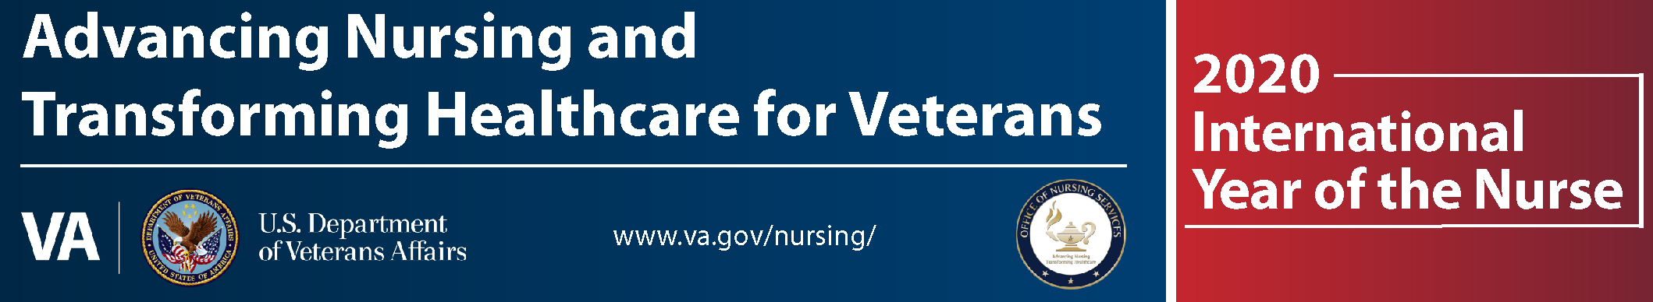

Heroes Recognized in New Orleans with Lawn Signs

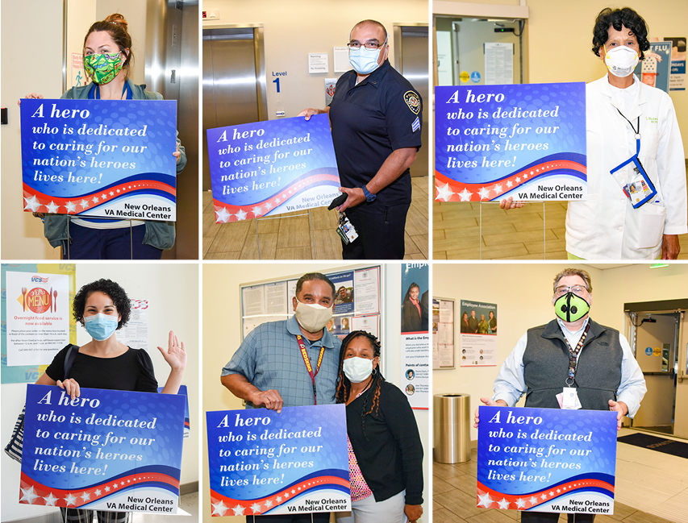
1st row: Maegan Guccione, Richard Reyes, Inez Victorian
2nd row: Xiomary Matos Rodriguez, Russell Bailey and Shauna Patterson (spouses), Jim Tardie

NOLA Medical Center Director Fernando Rivera distributed over 800 yard signs to nurses and other essential personnel to “let everyone know you are heroes taking care of America’s heroes”.
Rivera continued “The signs show that you are dedicated to taking care of our nation’s Veterans. Although you go about your mission humbly, I’m tremendously proud of the work you do and so is our community.” ONS could not agree more!

