Integrative Health Service at the San Francisco VA

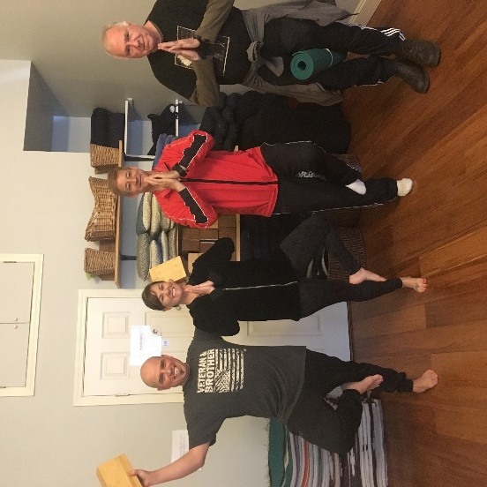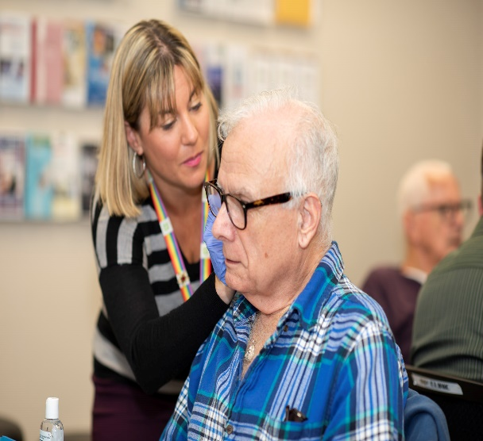
The first SF VA yoga class at Bend NP Hildebrand providing Battlefield Yoga Studio. Acupuncture to Charles Lord
Left to Right: Joseph Zielinski,
Caitlin Hildebrand, Orlando Tyson,
and Mike Zonta

Caitlin Hildebrand, MSHAIL, MSN, RYT500, AGPCNP-BC, is Nurse Practitioner and Nurse Manager for the Integrative Health Service at the San Francisco VA. She brings her passion and skills in whole health, especially mindfulness and yoga, to serve both veterans and staff. An accomplished author, whose book on mindful journaling for self-care was published in Spring 2020, she leads staff groups and trainings on mindful and intuitive eating. She has provided educational workshops, including continuing education for nurses, dieticians, and mental health professionals both locally, for the VISN and nationally. This content includes practical ways clinicians can coach veterans on how to improve their relationships with food and body image, in a way that creates lasting change and well-being. NP Hildebrand has attended multiple trainings to hone her curriculum and will be co-facilitating a pilot group for veterans with a dietician colleague this fall. She will be utilizing her significant experience in leading in-person and virtual mindfulness groups. Indeed, she spearheaded rapidly offering multiple virtual groups to meet the needs of veterans and staff due to COVID 19, including groups on mindful practices for quitting smoking, pain management, and Mind-Body medicine.
One veteran, John Twaddell, who has been participating in multiple mindfulness groups with NP Hildebrand wanted to share “Before I learned of the Integrated Whole Health programs available to veterans, I was in a constant struggle to overcome many physical and emotional obstacles. With the encouragement and unrelenting compassion of the professionals of the SFVAMC, I would not know this profound alternative life I am now living. The mindfulness practices, the encouragement of spiritual and mental healing, and the engagement of experiencing the journey with the health care professionals, who are the core of the Whole Health program, have allowed me to regain my self-respect. I have learned how to love and care for myself… I salute the VA and its leadership for recognizing the needs for wider ranging medical practices in the 21st century.”
Overall, NP Hildebrand is both a clinical and administrative leader in Whole Health, and in care more expansively at the San Francisco VA. In addition to leading quality improvement for Nursing Service from 2016-2020, she also served as Acting Chief of Advanced Practice Nursing facilitating the implementation of Full Practice Authority and served clinically in Primary Care and virtual TelePrimary Care. Currently, in addition to leading the team of Whole Health nurses, she serves as a Nurse Practitioner in the interprofessional Integrative Health and Wellness Clinic, provides virtual COVID screening visits, and is Assistant Clinical Professor for the UCSF School of Nursing, where she serves as a lead preceptor in the EdPACT Nurse Practitioner Residency program. She is a Fellow in Integrative Medicine at the Andrew Weil Center for Integrative Medicine at the University of Arizona, and received her Master’s in Healthcare Administration and Interprofessional Leadership from UCSF, Bachelors and Masters in Nursing from the University of Pennsylvania, and Bachelor of Arts in Psychology and English from Swarthmore College.

