Lori Hoffman Hogg Honored with NIH National Cancer Institute Director’s Award of Merit

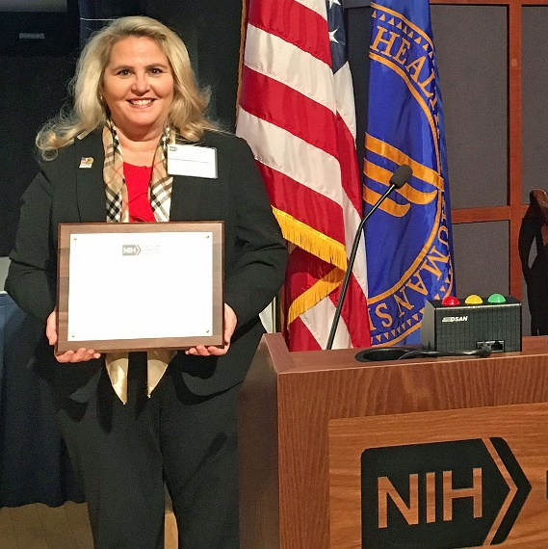
Lori Hoffman Hogg, MS, RN, CNS, AOCN® is the ONS Clinical Nurse Advisor for the Oncology Field Advisory Committee and VHA National Program Manager for Prevention Policy at NCP. She received the NIH National Cancer Institute Director’s Award of Merit in recognition of outstanding leadership and contributions to the development of National Cancer Health Objectives for Healthy People 2030. It was presented on 12/6/2019 by Dr. Norman Sharpless, Director, National Cancer Institute, U.S. Department of Health and Human Services, National Institutes of Health.
Lori Hoffman Hogg receives NIH award

