VHAGLAHS Integrative Health and Healing Nurses

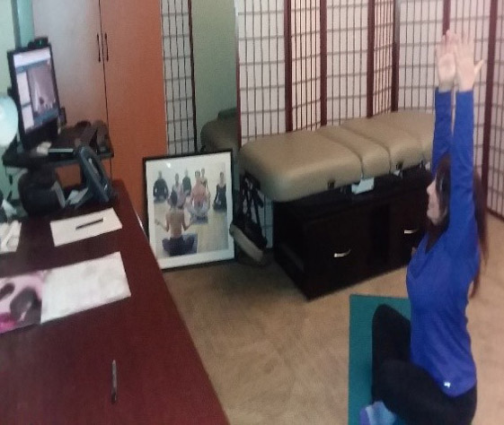
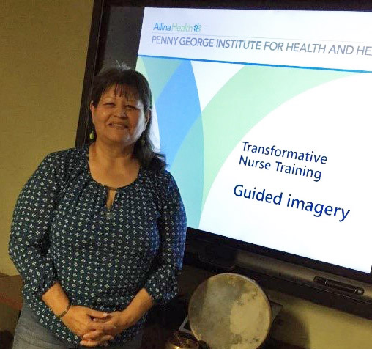Elizabeth Marin RN Terri Telligman RN, HNB-BC

Veterans Health Administration Greater Los Angeles (VHAGLA) has two Holistic Nurses in the Integrative Medicine Section of the Medicine Service. We feel very fortunate to be able to offer a choice of Complementary and Integrative Health (CIH) modalities to our Veterans. The iRest Yoga Nidra meditation groups, Meditative Movement groups, and drumming group are holistic nurse run groups. iRest is a 35-minute guided imagery meditation. Meditative Movement is a combination of meditation and yoga. The group is designed to be accessible to all physical ability levels. The drumming group combines meditation and relaxation exercises along with drumming that creates a sense of group empowerment. In addition, we offer the Introduction to Meditation and Relaxation, a four-week group introducing patients to four different meditation styles. This group is run as a collaboration with holistic nurses and mental health. Due to COVID-19 precautions these groups are now being held virtually over the phone and/or via Video Connect. We have Healing Touch outpatient clinics that provide individual healing touch sessions to patients. These clinics are offered at 3 different locations, and healing touch is also offered during group acupuncture to enhance the experience. Our programs are targeted towards enhancing Whole Health for all Veterans but are particularly popular for Post Traumatic Stress Disorder (PTSD), chronic pain, anxiety, and depression. The holistic nurses are available to other staff as resources and mentors, and facilitate, along with the nurse educators, a Transformational Nurse Training class that provides holistic nurse training for staff. Some of the practices taught in this class include comfort massage, aromatherapy, guided imagery meditation, and breathing exercises. This class helps spread the use of holistic modalities throughout the VHAGLA.

A quote from one our Veterans:
“It is really hard to quantify the benefits of this class (Meditative Movement). It helps me navigate the world in a calm and positive way. It keeps me centered and focused on the healthy aspects of my life…. ever since the COVID-19 shutdown, this class has actually increased in it’s importance to my life….. This class lowers my stress and enables me to operate in this crazy world with patience and reduced anxiety.”

