Home Telehealth Making a Difference
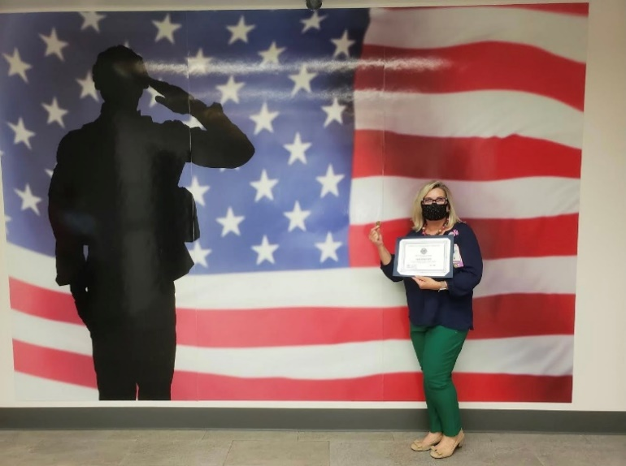
Lori Bruce BSN, RN, Home Telehealth Care Coordinator

A Rural heart failure (HF) patient had not been responding to Home Telehealth (HT) calls regarding his HF issues, which sometimes is typical for a few days with this patient. On the morning of Monday, JUN 1, 2020, HT received a family member call from the patient's sister (who lives in another state). The patient's sister shared concerns noticed by the patient's brother over the weekend when visiting the patient. The brother goes every weekend to set up his medication box for the week. The patient was a little confused, weak, "hungover," medications missed (2-3days), and observed with bowel and bladder incontinence that was not cleaned up from the floor. The brother attempted to get his brother to go with him to his home but refused. Since Saturday, the veteran had not returned calls to his family members, and the sister was concerned.
With the family's updated information, I advised I would call Adult Protective Services (APS) as they would be able to assess the patient in the home and report any current health or self-harm issues along with initiating home assistance if necessary. The HT Care Coordinator called APS, made a report, and discussed concerns of immediate assistance. APS was able to make this a high priority. APS visited with no luck of the veteran answering his door. The SW mentioned the patient's vehicle was in the driveway, and a dog was barking when she knocked on the door. I felt something was not right because the veteran does not go anywhere without his dog. HT immediately notified the local Sheriff's department about patient health and welfare and need immediate assistance. The Sherriff’s department was able to enter the patient's home, finding him lying (very sluggish) in his kitchen where he had collapsed. EMS was notified, and the patient was taken to the local emergency department (ED) for evaluation. Before the patient arriving at the ED, HT Care Coordinator notified the ED charge nurse to report on the patient’s history and safety concerns of being discharged home alone. HT requested the patient's family be notified before discharge or have SW see him in the hospital for further assessment and needs.
The patient was treated for dehydration and released to his brother's care early the next morning. HT was able to work with the PACT team on getting a family meeting to address the patient's safety concerns and living alone. Since this incident, patient has moved to be with family and continue care with a nearby VA.
The family was very thankful for the ongoing and excellent care that HT provides for their brother, who lives alone and can be a challenging patient. His sister shared, "my brother always tells me how much Lori cares for him. We cannot thank you enough for what you do."
**As a nurse in HT, this is why OUR TEAM makes a difference. We can develop relationships with our patients and their families, advocating for the highest-quality of care.

Lori Bruce BSN, RN
Home Telehealth Care Coordinator
Lori.Bruce@va.gov

