Susan Leitheiser, MS RN FNP-BC; ADPCS
Sioux Falls VA Health Care System
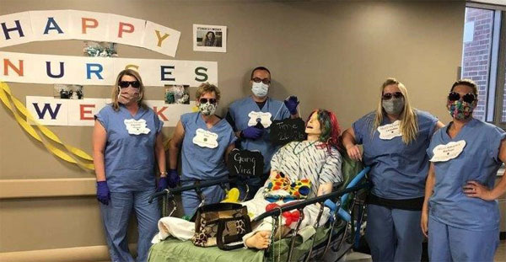
Ms. Susan Leitheiser serves as the ADPCS in Sioux Falls, SD. Her Veteran’s Affairs professional journey began 16 years ago as a Primary Care Nurse Practitioner for Sioux Falls. She became the Chronic Disease management (CDM) coordinator, enabling her to attend national meetings and telehealth conferences. Her work in CDM demonstrated significant impact on outcomes such as reduced bed days of care, and she emphasizes that it was rewarding to see Veteran outcomes improve after creating change. Her work created opportunities to meet VHA leaders and to learn from the perspectives of other roles. She recently became the ADPCS at Sioux Falls, and this shift in responsibilities has been extremely rewarding. Leitheiser states, “I would not want to work anywhere else!”
Ms. Leitheiser maintains enthusiasm about the profession of nursing and the multiple roles nurses fill, such as treating patients, education, and leadership. She pointedly learns from every experience, and she readily points out the important role that her team plays in accomplishing the work necessary to provide high quality care to Veterans. She refers back to employees and her team for her source of inspiration.
Ms. Leitheiser maintains work-life balance by prioritizing her family and friends. A proud grandmother, she states, “…Nothing beats the greeting when they see you and run towards you shouting Grandma, Grandma!”.
As a nurse executive, she acknowledges the importance of maintaining a positive work culture by maintaining her own positive attitude. Though she stresses the importance of leadership solidarity, she affirms listening to the front-line staff is very important for hearing alternatives that an administrator might not consider. Ms. Leitheiser believes that staff are looking to leadership for encouragement on how to thrive during the COVID-19 pandemic. Her advice to others’ in leadership roles is to keep a positive attitude, continue to let staff know healthcare is a team approach, and everyone’s thoughts matter.

