ONS Mental Health Field Advisory Committee

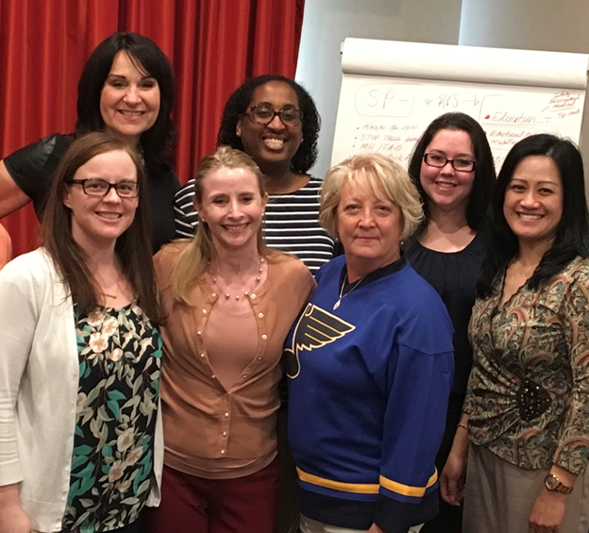
According to the APNA Scope and Standards of P-MHN (2014), “Psychiatric-mental health nursing is the nursing practice specialty committed to promoting mental health through the assessment, diagnosis, and treatment of behavioral health problems, mental disorders, and comorbid conditions across the lifespan. Psychiatric mental health nursing intervention is an art and a science, employing a purposeful use of self and a wide range of nursing, psychosocial, and neurobiological evidence to produce effective outcomes.”
The ONS Clinical Practice Program was developed by the Office of Nursing Services to support clinical practice through the development of evidence -based products and resources, develop policies in coordination with other VHA program offices, and to disseminate communication to the field. The CPP program is made up of various Field Advisory Committees (FAC), one of which is the Mental Health FAC. The MH FAC is led by Dr. Elizabeth Czekanski, DNP, RN-BC, NE-BC, VHA-CM, Mental Health Clinical Nurse Advisor and is composed of a team of mental health field-based nurses. Dr. Czekanski also collaborates closely with the Office of Mental Health and Suicide Prevention (OMHSP) and other VHA program offices on all matters related to psychiatric-mental health nursing.
1st row: Karin Glenn, Kristy Theis, Kat Zervas, Yurlene Dela Cruz 2nd row: Elizabeth Czekanski, Melissa Smith, Kayla Cross.
The Mental Health FAC is committed to promoting professional mental health nursing and has produced several products which help to educate and support nurses in the field. The Mental Health FAC consists of the following members:
- Dr. Kimberly Bronson, RN PMHNP-BC, Deputy A. Director Patient Care Services, Durham VAHCS
- Kayla Cross, MSN, MA, PMHNP, Nurse Manager, Mann-Grandstaff VAMC
- Dr. Yurlene Dela Cruz, DNP, MSN, RN-BC, Chief Nurse,Mental Health & Education Fayetteville NC
- Dr. Nancy R. Faulk PhD, RN, NE-BC, Chief Nurse Mental Health Service, Shreveport VAMC
- Dr. Karin Glenn, DNP; PMHNP-BC, Nursing Professional Development Practitioner, Hines VAMC
- Joan Jenkins, BSN, BA, RN, Louis Stokes VAMC
- Amanda Miller, MSN, RN, Nurse Manager, RRTP Cincinnati VAMC
- Linda Shinn, BSN, RN-BC, Assistant Nurse Manager, Roseburg VA Health Care System
- Melissa A. Smith, MSN, PMHNP-BC, PMDB Coordinator, Corporal Michael Crescenz VAMC
- Kristine Theis, FNP, MSN, RN, Behavioral Health Nurse Clinical Coordinator, Boise VAMC
- Kat Zervas, MSN, RN, Patient Care Service, Jefferson Barracks, St Louis, MO
Training
(TMS trainings require search for course number)
Essential Skills and Strategies for Nurse Led Group Facilitation Video
Mental Health Environment of Care Checklist (MHEOCC) Video
Therapeutic Communication and Patient Engagement (TMS 36364)
Therapeutic Communication Application: Build Engagement and Trust (TMS #36654)
Therapeutic Contraband & Hazardous Items Check (TMS 38944)
Mental Health Nursing Orientation: Webinar Series:
Safety and Environment of Care (#37090 on demand)

Communication (#37534 on demand)
Patient-Centered Care (#37980 on demand)
Psychiatric Nursing Assessment (#38567 on demand)
Common Mental Health Dx (#39015 on demand)
Psychopharmacology (#39372 on demand)
Resources
ONS MH FAC Competency Tool This tool is intended to be utilized as an adjunct to the competency process in place at individual facilities. It is not prescriptive, nor must it be used in its entirety. These are suggestions for building initial inpatient mental health RN competencies based on a crosswalk of the 2014 APNA Scope & Standards of Practice and concepts from Donna Wright's competency assessment model.
Psychiatric-Mental Health Nursing Orientation Guide
RN Guide for Psycho-educational Groups (updated May 2015)
Caring for Veterans With PTSD and Mild TBI

