Advanced Holistic Nursing in VANJHCS

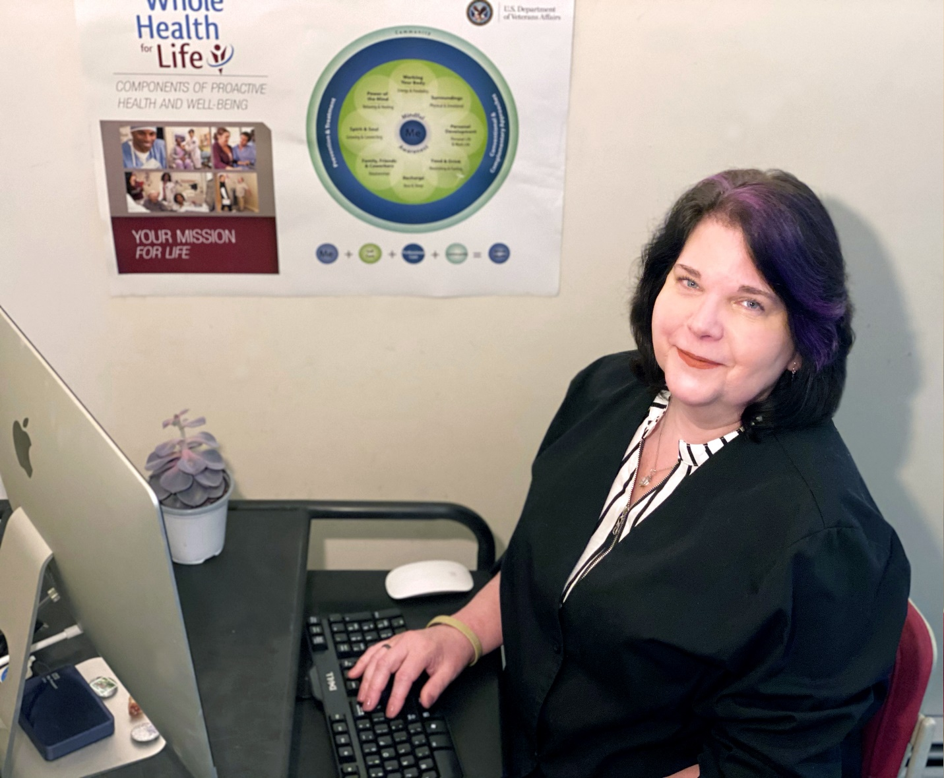
I am Maryellen Marciniak, MSN, RN, NBC-HWC, CDE, AHN-BC, an advanced practice nurse, nationally board certified in health and wellness coaching, a Certified Diabetic Educator, board certified in Advanced Holistic Nursing as well as nursing education who has been with the VANJHCS for the past 9 years.
My career in nursing started at acute care facilities within intensive care/cardiac care and emergency departments. I later became a certified occupational health nurse dealing with employee care and designing employee health/wellness and safety promotion programs, occupational nursing manuals (that introduced employee wellness concepts) for Aerospace/Automotive divisions and I have authored articles establishing the occupational nurses’ comprehensive role within Industrial Health and Safety Programs as well as designing health and wellness programs for the community at large.
All of this has led me to the pinnacle of my career as a Clinical/Nurse Health Coach within VA New Jersey. It is a privilege and honor to partner with our Veterans, their care givers and our employees. I use evidenced based skills that facilitate sustainable behavior changes – a combination of Nursing theory and Whole Health Coaching strategies and techniques. By assisting Veterans to recognize their inner wisdom – they are given the space to identify and state their values and attain goals through an action plan that is based on their individual mission, aspiration and purpose towards their health. By employing Whole Health Coaching along with my other nursing skill sets, I have found that I can be a catalyst to both individual’s and groups’ positive behavior change. The Clinical Health Coaching groups that I facilitate include, Type 2 DM, Tai Chi Easy/Adaptive Tai Chi, Mindfulness, as well as working with our VA weight management program - MOVE! – as of late, these groups have been switched to Video platforms. Health Coaching groups are crafted as the Veterans’ needs present themselves - a Healthy Heart and Health Coaching group is being crafted and will soon be implemented.
It is also my privilege to mentor our VANJ Onsite Whole Health Champions – individual employees who represent each of our Ambulatory Care sites, these individuals are tasked with:
Describing the philosophy and goals of Whole Health and Whole Health Coaching in the clinical setting to employees, Veterans and Caregivers.
Enhancing and supporting Whole Health and Whole Health Coaching framework, concepts and skills with other members of PACT through role modeling and serving as the Onsite Whole Health resource/liaison.
Notifying the setting of all implementation tools and strategies as they are approved to support Patient Centered Care through Whole Health and Whole Health Coaching.
Nurse/Clinical Health Coaching is what matches my values – mission, aspiration and purpose. I can weave multiple nursing theories, including complimentary and integrative health modalities. into my Nurse/Clinical Health Coaching practice. By utilizing the Circle of Health and the Components of Wellbeing, I am able to provide a framework to my Nurse/Clinical Health Coaching that is individualized and Veteran centered - I am able to provide the space for individuals and groups to access their greatest healing potential by partnering with not only our Veterans but also their Caregivers, as well as my colleagues and staff.
I have always practiced this way throughout my long career but there were never words or a conceptual framework or theory that described the Clinical Nurse Health Coaching role – until now - and I have found my home.
Thank you to all the dedicated nurses, colleagues and staff of the Veteran Administration – whose works and caring brings out the best in all of us.

