Decorated War Veteran and Primary Care Nurse Mary Wissman

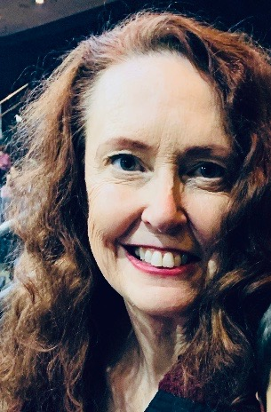
Captain Mary Wissman RN served in the US army 2008-2010. She was stationed at Forward Operating Base (FOB) Salerno Afghanistan treating soldiers and civilians on the front lines. During Captain Wissman’s tour, she withstood an attack on the unit by suicide bombers that lasted over 48 hours. She cared for patients in the unit at the time of the initial bombing, and for those injured as a result of the continued bombing. During the evacuation, she duct-taped the paper medical records of the survivors to their chests so that the care they received would travel with them back to the States. Captain Wissman was awarded the Bronze Star for her heroic efforts in the service of her nation.

Upon discharge from the service, Ms. Wissman turned her attention to serving her fellow veterans. In 2016, she joined the Veterans Administration (VA) as part of the Wilmington Delaware Primary Care Team. Ms. Wissman established the structure and processes that allowed her site to have the first Community Based Outpatient Clinic (CBOC) in the Veteran Integrated Service Network (VISN) 4 to provide prosthetics services outside of the main facility. Ms. Wissman earned board certifications in both Care Coordination and Transition Management through the American Academy of Ambulatory Care Nursing (AAACN) and as an Emergency Room Nurse through the American Nurses Credentialing Center (AANC). Ms. Wissman became the first VA Care in the Community (CITC) nurse navigator to work in the CBOC setting, fostering a deep connection between the VA and the private sector in support of coordinated care.
Mary Wissman BSN, CCCTM, CCNE

Ms. Wissman has formed strong connections with her South Jersey VA nurse colleagues. She led the nursing team supporting Atlantic City’s inaugural “Stand Down for Homelessness” outreach in South Jersey. She also partnered with South Jersey community providers in suicide prevention efforts and co-organized the “Flags for the Forgotten”, a VA display at her CBOC with local VSO’s in bringing awareness to the 660 Veteran Suicides every 30 days.

Ms. Wissman recently deployed to the critical care units at the East Orange VA facility during the COVID crisis. Upon returning, Ms. Wissman took on the operations of her local VA clinic in the support of management during the VA/FEMA SJ Strike Force endeavor to the Southern New Jersey Civilian Nursing Facilities as part of the VA’s 4th mission. Her efforts in the support of the local VA clinic operations allowed the local management team to attend to the needs of over 150 VA nurses from around the nation who came to serve Atlantic County.

