Joan S. Whelan Schwartz, FNP-BC

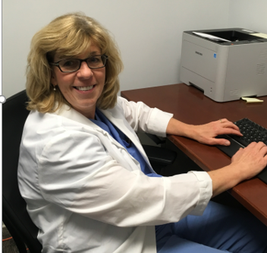
I started out as the first Urology NP at James J. Peters VA Medical Center, in Bronx, NY. Since November 2019, I became the National Study Coordinator VA INTREPID which is the study of treatment to prevent amputations in patients with diabetes, the leading cause of amputation in Veterans. As one of two National Study Coordinators, I assist 14 site coordinators and hold bi-weekly calls to share and exchange information to 28 other VAMCs.
When COVID-19 pandemic was at its peak in NYC, I volunteered to work at Hot Triage. which is a mobile clinic van parked directly in front, to triage Veterans with COVID-19 like symptoms. I triaged every patient in need and transferred Veterans with higher acuity to our Emergency Department. The Hot triage NPs collaborated to provide adequate COVID-19 coverage. We all stayed healthy. Furthermore, we stepped up to the challenge with open arms and were very flexible in learning and providing the best care when triaging Veterans and employees.
I love being able to serve our Veterans in collaboration with our interdisciplinary team. Now that the transmission rate is lower, I am part of Operation Warped Speed which is focuses on planning for the vaccine initiative that is participating in the double blinded 1 to 1 randomization study with a one-time administration of the placebo/investigational vaccine.
I want others to learn of the many different career paths NPs have within the VHA. I have worked in two different departments within JJP. Advancement of nurses and APRNs is important and personal to me and the VA has supported me and my practice.

