Coatesville VA Nurse Practitioner Faces COVID-19 in NJ

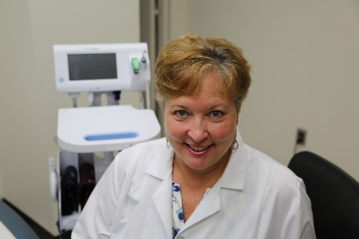
Mary Maguire, an Adult Nurse Practitioner at the Coatesville VA Medical Center, did her part to help Veteran patients fight the novel coronavirus by serving on the frontlines of care at the State Veterans Home at Paramus, New Jersey.
Coatesville VA Medical Center supported VA's Fourth mission assignments with direct clinical care, testing, education and training at the State Veterans' Home (SVH).

Maguire has been at Coatesville VAMC for over 7 years and has 36 years of nursing experience. Normally attending to the Veterans recovering from substance abuse, Post Traumatic Stress Disorder and treating residents in the homeless domicile, she arrived on April 27 in NJ with an initial team of 14 from different medical centers across the region. Eight of those were from the Coatesville VAMC.
Mary Maguire, CRNP has 36 years of nursing experience. Maguire has been at Coatesville VAMC for over 7 years and attends to Veterans recovering from substance abuse, Post Traumatic Stress Disorder and treats residents in the homeless domicile.

Surrounded by Coronavirus
Early on Maguire did not even consider volunteering and describes her reaction to the first calls for volunteers. The impact of being surrounded by coronavirus every day at work, at home and on the nightly news in those first few weeks began to take its toll. "The more I was doing, the more fearful I was becoming of the whole thing and finally I said, 'okay that's it. I'm done!'"

First In
An avid scuba diver, Maguire said that she is always the first in the water and she feels she must embrace challenges. The phrase "I'm done" doesn't mean "I quit," it means "I've had enough, let's fix this.” Having never deployed before, Maguire's family, except her husband, did not support her desire to volunteer but she didn't relent. After 10 days she sat down with her husband again to explain why she had to go. "These Veterans need my help and I can't sit here. I must go. I must do this. I'm jumping in."
The next day another email asking for volunteer Nursing Practitioners arrived from the Mission Incident Commander, Nancy Schmid, who would oversee things at the SVH. Schmid also works here at Coatesville VAMC as the Associate Director of Patient Care Services. "I know Nancy, I trust Nancy," said Maguire and picked up the phone and once Schmid promised they would have the personal protective equipment required to take care of the patients, the decision to volunteer was easy. "Our Nursing Practitioners are essential to the success of this mission because they are needed to stabilize the patient illness and promote recovery" said Schmid. "Once I saw that Mary was volunteering, I knew that no matter what was in store for us, those Veterans were going to get the best care that we could provide."

Where to Start?
The team at the SVH was experiencing staffing shortages due to COVID-19 infections and needed more staff with the right skillset to provide quality care to their Veterans. One of the priorities was to improve the quarantine and isolation procedures and educate to on-site nursing and staff using CDC guidelines.
Maguire split 6 units with a total of 300 beds with another Nurse Practitioner and started assessing patients. "I did whatever needed to be done for the Veterans. I helped direct medical care, prescribed treatments, transferred Veterans to the hospital for higher level of acute care, assisted in application and adherence to infection control guidelines, and worked with on-site staff so that we could get COVID-19 under control."

A Very Personal Perspective
Maguire's father is a Navy Veteran, so she approached her job from a very personal perspective. "Okay, this [Veteran] is my dad and I treat everyone like they are my family. How would I want to go through this with my parent?" This meant providing care for all the Veterans and their families at close range. “I would call the families and explain to them, we [VA], are not here because we were told to come here, we here because these are our Veterans and these guys deserve that care," said Maguire. "Once they processed the anger and the anguish that their loved one was dying and they couldn't see them, they would thank us for coming in."
Due to COVID-19, families were not permitted to be present to hold their Veterans' hand when they passed. Maguire would walk them through everything they were doing to make sure the family knew their Veteran was cared for and would die with dignity. "Thankfully there was a team that came from the VA, who helped with the communications with the family. Their mission can't be understated. They used technology so that families could see their loved ones and say goodbye." Unfortunately, I had to talk to many families about end of life decisions over the phone as COIVD prevented the typical family face to face communication. These conversations are difficult and emotionally painful to have on the phone for most families.

Consider Volunteering
Maguire, who returned home on May 10, offers the following thought to nurses who consider volunteering. "Do it because it empowers you. It empowers you over the fear of becoming sick. You have to find a way to go to work and take care of your patients. If you prepare yourself and you go in there and do what you are supposed to do, you will know that you can come back to your VA and do whatever needs done."

Since April 27 Coatesville VAMC has deployed 15 people across Pennsylvania and New Jersey to support healthcare facilities hit hardest by the coronavirus and who were on-hand supporting nurses caring for the most at-risk Veterans.

