# Tessa Turton-Thompson, NP

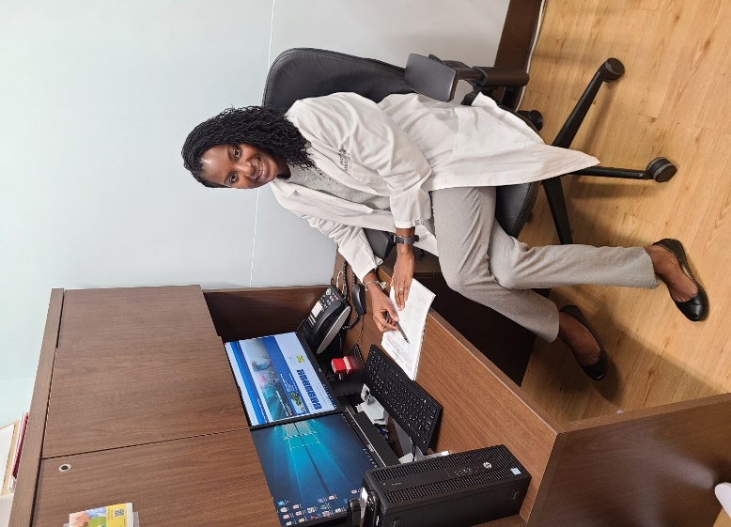I am the Occupational Health NP at James J. Peters VA Medical Center (JJP), in Bronx, NY. My role is to secure the health of employees while they are at work. My practice includes managing the clinic, triaging employees who get injured or sick at work, performing physical exams, managing immunization requirements and the flu program (i.e. ensuring adherence to the national flu direction), and screening for hazardous exposure. I manage the unknown aspects of safely running the facility.

During the COVID-19 pandemic, I instituted changes to meet the health needs of our staff. I ran Hot Triage for employees. I also implemented Return-to-Work (RTW) clearance at JJP by using CDC guidance, to ensure that staff are returning to work safely. To further ensure the safety of all involved, we quickly developed a TeleHealth program to screen, triage, and evaluate for COVID-19. It was a success, with over 345 telehealth encounters and 147 RTWs. Between March to May, Occupational Health encounters increased by 300%. Even now, we are still testing and actively monitoring employees.

I witnessed the dedication of staff in supporting the health of Veterans and each other. We truly provide quality care to Veterans and are at the forefront of assisting employees. Stressful situations are where one sees true character. I am proud to work in a place where I see the integrity and value of my colleagues shine through - people stepped up during the pandemic. I feel compelled to share my story to reflect the work our facility and its staff practice to provide quality care to Veterans. Occupational Health is an integral part of the picture, my practice reiterates to employees that they are vital to the facility’s mission to serve Veterans. It is an honor to care for people in times of need and uncertainty. We all collaborated to ensure that everyone (including Veterans and staff) are safe.

Speaking of caring for employees, self-care is important! In my spare time, I love to bake and cook with my two little girls. This is a quiet time to relax and bond with them.