My role as a Nurse Educator
As a nurse educator, it can be hard to know if your teaching has made a difference. I always hope that my efforts have had an effect that reaches the Veteran, but often the feedback I get is in the form of evaluation data rather than the lived experience of nurses.
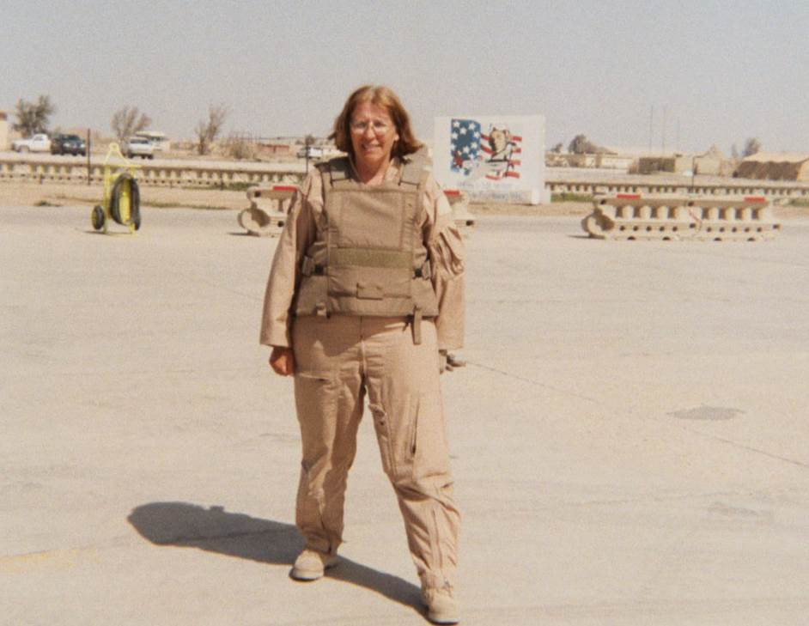
That my work helps Veterans is especially important to me as a Veteran myself.
I am honored to share a story of how as a nurse educator I made a difference. As part of my nurse educator role at the Minneapolis VA I have taught a basic EKG interpretation class for years. I had just created a virtual version of the class to provide distance learning for another smaller VA facility. Although since COVID-19, this is the new normal, at the time it felt like a new concept. Several days after this class ended, I was contacted by a fellow nurse educator at this same smaller site that I taught the class with a story of how I had made a difference.
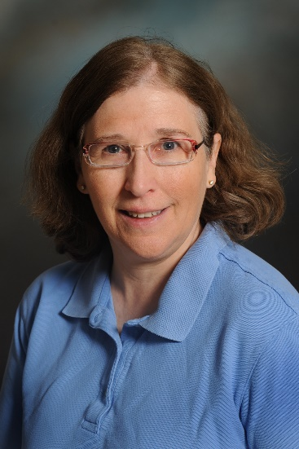
After completing the course, an RN caring for an urgently ill patient was able to recognize a Second-Degree AV block immediately as a serious arrhythmia and get the patient transferred to the right level of care. This nurse credits her ability to do so based upon the information and skills learned in the class I taught. I am so proud of how I and all my fellow nurse educators can improve clinical care.

Cleo Bonham, MSN, RN, CCRN

