Nurse Passport Program Improves Cultural Understanding

In May 2020, Dr. Katherine Colbert, DNP, RN, CCRN-K, Nursing Professional Development Practitioner, and Nursing Education & Performance Improvement Program Manager, developed and implemented a Virtual Cruise for her nursing staff to reflect on2020 as the Year of the Nurse. A difficult task to accomplish in the world of COVID, Dr. Colbert created passports and “trips” to each of our destinations, including virtual learnings that reviewed nursing practices and guidelines in the country being visited. A favorite amongst her nurses, Italy, was the picture-perfect destination as Dr. Colbert decorated and provided a socially distanced gathering consisting of food from Italy as well as teaching her staff a card game unique to Italy called Briscola. Not only did this provide an excellent learning opportunity on the culture of Italy, it also provided a time of team building and fellowship amongst her team of nurses, especially in the trying times of COVID. Additionally, while “docked” at each destination, Dr. Colbert included a passport entry question in which her nursing staff answered a question related to our travels. An example of this from our stop in London, England was the question, “what characteristics do you share with Florence Nightingale?” after taking a virtual tour of the Florence Nightingale museum in London. These questions truly helped nurses reflect on their own journey through the profession of nursing and provided a sense of reflection and resiliency amidst the COVID pandemic. Dr. Colbert is a valued and respected nurse manager amongst her staff and our appreciation to her knows no bounds. She is a gem in a coal mine and her support and efforts of her staff does not go unnoticed!

List of countries visited:
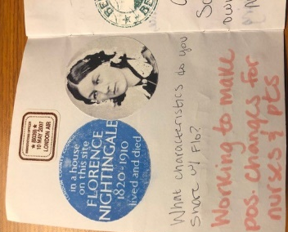
London, England
Berlin, Germany
Paris France
Florence, Italy
Mozambique, Africa
Phuket, Thailand
Manila, Philippine Islands
Honolulu, Hawaii USA
Cancun, Mexico
Richmond, Virginia USA

Staff quotes

“Dr. Colbert started the virtual cruise during the week of the nurse and concluded in the week of the Nurse Professional Development Specialist. I know she worked very hard on coming up with these entry questions and activities. This was all a way to build our resiliency and improve our work environment in a time when she knew we were all picking up extra and doing more for COVID-19. There was true team building and staff development through the virtual cruise. It was an amazing experience from an amazing supervisor, colleague, and friend.”
- Linda Nierman, MSN-Ed, RN
CPT, US Army (ret)
Nursing Professional Development Practitioner

“Dr. Colbert has set the bar in the development of innovative ways to facilitate education, teambuilding, and culture competency. Her attention to detail with the creation of all our virtual destination ports have been world class. The level of creativity, time, and effort to make sure her staff are well supported during these times of COVID just cannot be match. Dr. Colbert has inspired me to also incorporate a virtual Caribbean cruise as a teambuilding event in line with my unit Adventures theme competency fair this year. The results of great leadership are shown when you can embrace new ideas and share positive outcomes. Dr. Colbert’s presence in our educator group and organization is invaluable! I am truly grateful for her love, support, and excellence in leadership.”
- Katrina Bates, MSN, RN
Nurse Professional Development Practitioner

Dr. Colbert has fostered an environment that encourages fellowship, sisterhood and love that she shows us daily that makes us want to be better for not only ourselves but for the staff and families we encounter each day.
- Shelia Wright

