Office of Nursing Services Geriatrics and Extended Care Field Advisory Committee

The Office of Nursing Services Geriatric and Extended Care (GEC) Field Advisory Committee (FAC) is made up of VA nurses who provide nursing practice and leadership at the point of care in various GEC programs throughout the nation. With Veterans over the age of 65 being one of the age groups who more likely use VA benefits compared to Veterans of other ages,¹ we have nursing field representation of various nursing roles (e.g., clinician, educator, researcher, and administrator) and from a variety of GEC programs such as Home Based Primary Care, GeriPACT, inpatient and outpatient geriatric evaluation, and hospice and palliative care.
The aim of the ONS GEC FAC is to help VA nurses in the field to provide excellent quality care to aging, disabled, and/or frail Veterans. We seek to improve Veteran-centered nursing care of Veterans in their continuum of care through education, policy promotion, and support of holistic and evidenced based practice. To this end and to promote VA’s overall mission, we collaborate with various program offices (e.g., Office of GEC, Office of Mental Health and Suicide Prevention, Center on Homelessness among Veterans, etc.) and participate/lead workgroups in various national committees (e.g., VHA Dementia Steering Committee, Office of Electronic Health Record Modernization [OEHRM] GEC Council, etc.).
The GEC FAC is led by Jenice Guzman-Clark, PhD, RN, GNP-BC, FAMIA, who has been the Clinical Nurse Advisor since 2013. In total, GEC FAC members have 281 combined years in the nursing profession, has been in the VA for a total of 178 years, and have worked in 14 different VA facilities throughout the nation. Products and projects that the group has worked on varies² and include staff training on a variety of topics related to nursing care of aging Veterans, competency document, orientation resource guide, and publications.
During the coronavirus pandemic, the following products were produced and/or had contributions from various GEC FAC members:
- COVID-19 A Clinical Resource Guide for Community Care Centers – will be posted in https://www.va.gov/homeless/Coronavirus.asp once available for dissemination.
- Lecture titled “Dementia Evaluation During COVID-19: When Face-to-Face Care is Not Possible.” Presented virtually at VA-ECHO webinar. TMS Item # 41962. Module available at www.tms.va.gov.
- Re-release of previously recorded lectures (e.g., Communication with Older Adults, Medication and Treatment Considerations of Older Adults, Physical and Mental Assessment of the Older Adult, Plan of Care for the Older Adult, and Safety of the Older Adult) as part of COVID-19 identified educational courses uploaded to the external VHA TRAIN platform to share with non-VA professionals.
Please reach-out to JeniceRia.Guzman@va.gov for further information re: the ONS GEC FAC.
References:
- National Center for Veterans Analysis and Statistics, May 2020. VA Utilization Profile: FY 2017. Accessed on 8/31/2020 from https://www.va.gov/vetdata/docs/QuickFacts/VA_Utilization_Profile_2017.PDF
- Office of Nursing Services, n.d.. Clinical Practice Program (CPP) Products. Accessed on 8/31/2020 from https://vaww.va.gov/nursing/cppProducts.asp
Anna Bober DNP, RN, GNP-BC, CMSRN  Patient Care Services  Richard L. Roudebush VA Medical Center  Indianapolis, Indiana | 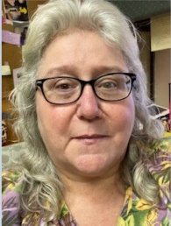  Marie Chandler, BSN, RN  Geri-PACT  Hershel “Woody” Williams VA Medical Center  Huntington, WV | 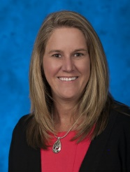  Dayna Cooper, MSN, RN – Director, VA Home & Community Care  Office of Geriatrics & Extended Care – VACO  Washington, DC
Jenice Guzman, PhD, RN, GNP-BC, FAMIA  Clinical Nurse Advisor  Southern Arizona VA Health Care System  Tucson, AZ | 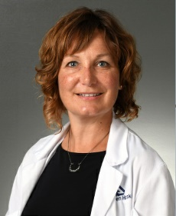  Maureen Haske-Palomino, DNP, MSN, APRN, GNP-BC  Inpatient Geriatric Evaluation  William S. Middleton Memorial Veterans Hospital  Madison, WI | 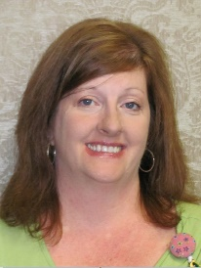  Jeanine Hutchinson, RN MSN  Home Based Primary Care  W.G. (Bill) Hefner VA Medical Center  Salisbury, NC
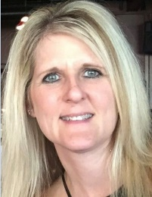  Traci Kistler, BSN, RN  Home Based Primary Care  Sioux Falls VA Medical Center  Sioux Falls, SD | Marygrace Ransome, MSN, RN  Outpatient Geriatric Clinics, GEM, CNHe, CLC, HBPC, & SVH  Central Virginia Veterans Healthcare System  Richmond, VA | Lyzz Caley Stewart, DNP, RN-BC  Rehabilitation & Extended Care Integrated Clinical Community  VISN 20 NW Health Network  Vancouver, WA
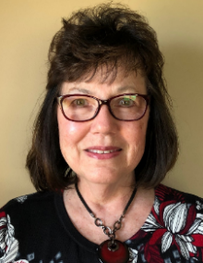  Ruby Wood MSN, MBA, RN  HBPC, Home Telehealth, and Virtual Care  VA Eastern Kansas Health Care System  Leavenworth, KS | Hadiya Williams, MSN, APRN-BC (ad hoc member)  Home Based Primary Care  Ralph H. Johnson VA Medical Center  Charleston, SC | 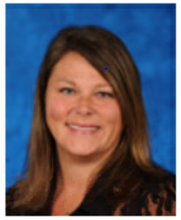  Kelly Morrow  Program Specialist  Clinical Practice Program  VHA Office of Nursing Services  Washington, DC

