# ONS Perioperative Field Advisory Committee

The ONS Perioperative Field Advisory Committee (FAC) provides guidance by implementing evidence-based practice, clinical expertise and resources to the perioperative field to promote Veteran-centered care and optimize surgical patient outcomes. There are 137 surgical programs throughout the VA system. These surgery programs performed 417,575 surgical procedures in FY19 ranging from complex procedures to ambulatory surgery center basic procedures. The FAC collaborates with other program offices such as National Surgery Office (NSO), National VACO Anesthesia Service, and the National Program office for Sterile Processing. Together, they work on directives, policies, workgroups and site visits.

The Periop FAC is led by Lisa J. Warner, MHA, RN, CNOR, Clinical Nurse Advisor for Periop and is comprised of 10 members with diverse backgrounds in perioperative nursing. The Periop FAC consists of the following members:

* Connie Garrett, MSN, RN-BC, CNOR, Perioperative CNL & Educator, Tampa, VAMC
* Vicky Marrs, MSN, RN, CNOR, CST, ACN-Perioperative Services, Central Texas, VAHCS
* Brian Parton, MA, RN, CNOR, OR Nurse Manager, Orlando, VAMC
* Suzanne Hook, MSN, RN, VHA-CM, Chief Nurse Admin & Operation, Baltimore, VAMC
* Lynn Gettrust, DNP, RN, ACNS-BC, Perioperative CNS, Milwaukee, VAMC
* Bill Stevens, MS, RN, CNOR, OR Nurse Manager, NSO Chair SAB OR NM, Pittsburgh, VAMC
* Michelle Andrejak, MBA-HCA, BSN, CNOR, OR Nurse Manager, Gainesville, VAMC
* Dina Remenar, MSN, RN, CNOR, RNFA, OR/PACU/Day Surgery Nurse Manager, Asheville, VAMC

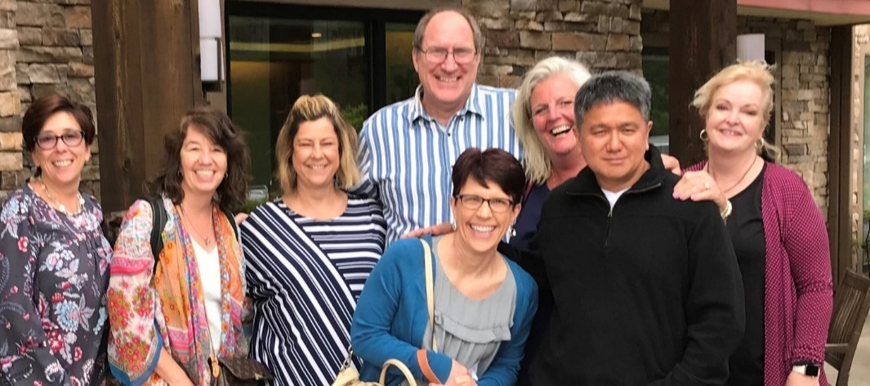

*L to R: Michelle Andrejak, Lisa Warner, Connie Garrett, Brian Parton, Lynn Gettrust, Suzanne Hook, Jonathan Ramos (past member) and Vicky Marrs.*

Here are some of the projects the FAC has been involved in and has worked on over the past couple of years.

* Updated the OR Staffing Methodology calculator and developed TMS modules.
* Created a national CPRS template for the OR Fire Risk Assessment to meet The Joint Commission (TJC) standards.
* Collaborated with the NSO on an AUSH Memo-Guidance for the Urgent Emergent OR Procedure for COVID 19 Patients.
* Approved a Pressure Injury Periop Risk Assessment Tool called ‘Scott Trigger’ that will be in the new Cerner electronic health record (EHR) and developed a CPRS Template.
* Developed Periop Care Plans for the new EHR using the Association of periOperative Registered Nurse (AORN) Perioperative Nursing Data Set (PNDS).

We are currently collaborating with Safe Patient Handling and Mobility (SPHM) group to address the needs in the intraoperative setting by working on reducing manual patient positioning. We look to create a plan and identify SPHM technologies and solutions to replace high risk care tasks involving manual handling of patients, such as lifting, pulling, pushing, positioning, and repositioning in the perioperative setting in order to reduce staff and patient injuries. Our focus is working with vendors to find innovative solutions to replace/substitute manual handling using technology such as ceiling lifts and forced air mattresses that can be validated and recommended for safe use to the field.

Here are some valuable resources available to the field:

* The Periop FAC SharePoint VHA OR Manager contains PD, Functional Statements, Standard Operating Procedures (SOP), Policies, Competencies and Helpful Web Links. <https://dvagov.sharepoint.com/sites/VHAORManager/default.aspx>
* Monthly Conference Calls with OR Nurse Leaders. Scheduled 2nd Monday of the Month. Invite through the group mail [VHAONSORNursingLeaders@va.gov](mailto:VHAONSORNursingLeaders@va.gov)
* AORN eGuidelines+ <https://aornguidelines.org/>
* Elsevier Periop Clinical Skills. They have all been downloaded in TMS. <https://dvagov.sharepoint.com/sites/VACOVHAONS/ClinicalSkills/SitePages/Home.aspx>
* Alexander’s Care of the Patient in Surgery, 16th ed. <https://www.clinicalkey.com/nursing/#!/browse/book/3-s2.0-C20160004576>
* Alexander’s Surgical Procedures

<https://www.clinicalkey.com/nursing/#!/browse/book/3-s2.0-C20090631111>

* Surgical and Endovascular Services Design Guide- Office of Construction & Facilities Mgt

<https://www.cfm.va.gov/til/dGuide/dgSurg.pdf>

* Saunders Nursing Drug Handbook 2021

<https://www.clinicalkey.com/nursing/#!/browse/book/3-s2.0-C20190004505>

* Vista Surgical V.3.0 2016 User Manual. VA Software Document Library

<https://www.va.gov/vdl/application.asp?appid=103>

There is a very robust OR Nurse Leader mail group. This provides a forum to ask questions about practice, policies, SOPs, and other perioperative questions. The email platform gives instant access to hundreds of years of experience. The OR nurse leaders are networking with 137 OR Managers and other perioperative nurses across the country to instantly find evidence-based practice on any subject matter. It never takes long to find an example of best practice that can be shared amongst peers to better patient care in all of our VHA Operating Rooms. This year has been like no other. The collaboration between all the facilities and the FAC has never been more evident. There were daily changes to patient care regarding the COVID 19 pandemic. No VA OR Manager was on an island. No VA OR Manager had to come up with solutions on their own. With just a quick email, members had instant responses to questions, examples of SOPs, and the latest guidance from the NSO, AORN, CDC and The Joint Commission. This was an invaluable resource for the perioperative nursing field.

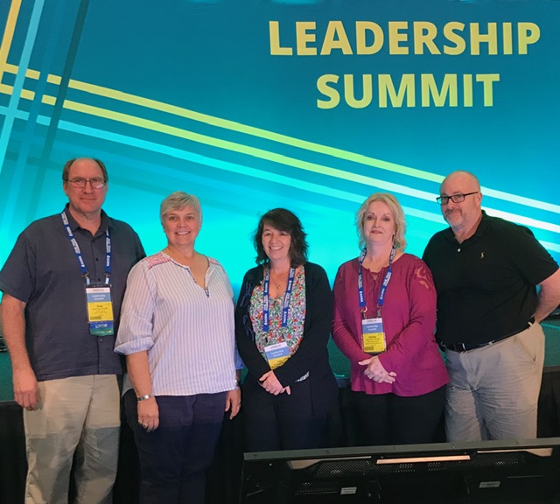

L to R: Brian Parton, Dina Remenar, Lisa Warner, Vicky Marrs, Bill Stevens.