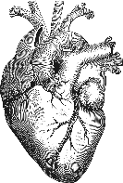

Office of Nursing Services Cardiology Field Advisory Committee:
Brief Program Overview:
The Cardiology FAC is an assembly of nationwide nursing experts, functioning in a diverse group of nursing roles within the VA. Cardiology FAC members serve as subject matter experts to the Office of Nursing Services and provide information, guidance and oversight to VHA Cardiology initiatives to ensure quality heart care.
Aims and Goals:

The ONS Cardiology FAC consists of the following members:
- Jennifer Ballard-Hernandez, DNP, NP, AACC, FAHA, FAANP, FAC Chair, Tibor Rubin VA
- Jasmine Fowler, MSN, RN, Cardiology Nurse Navigator, Harry Truman VA
- Cher Hagaman, MSN, NP, CCNS, Heart Failure Nurse Practitioner, Tibor Rubin VA
- Mary Keary, NP, Cardiology Nurse Practitioner, New York VA
- Caleb Queen, MBA, BSN, RN, ICU Nurse, Ashville VA
- Susan Roberts, NP, Cardiology Nurse Practitioner, Durham VA
- Yvette Twum-Danso, MSN, RN, CCRN-K, Columbia VA
- Cynthia Wilson, RN, Cath Lab Nurse Manager, Palo Alto VA
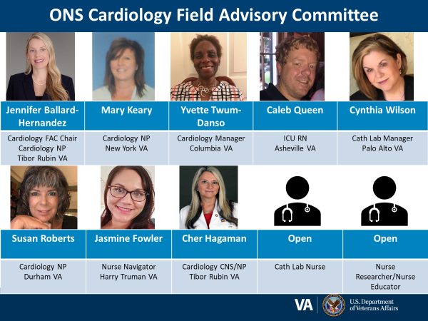

The ONS Cardiology FAC is committed to promoting professional cardiovascular nursing and has produced several products which help to educate and support nurses in the field. These products can be found at http://vaww.va.gov/nursing/cppProducts.asp.
- Educational programs
  - EES National Webinars:
    - Cardiovascular Care of Patients with COVID-19: A View From the Front Lines
    - Implantable pressure monitoring: CardioMEMs
    - 2020 Hypertension Clinical Practice Guideline Update
- Clinical Practice Guideline Development:
  - 2020 VA/DoD Hypertension Clinical Practice Guideline
  - 2020 VA/DoD Dyslipidemia Clinical Practice Guideline
- Guidebook
  - Telemetry Guidebook
- Products/Tools for the field
  - Cardiovascular disease management protocols
  - Competencies
  - HSP/SOP examples
  - Patient education handouts
  - Standardized EMR documentation

