Nurses Team up to Promote Safety

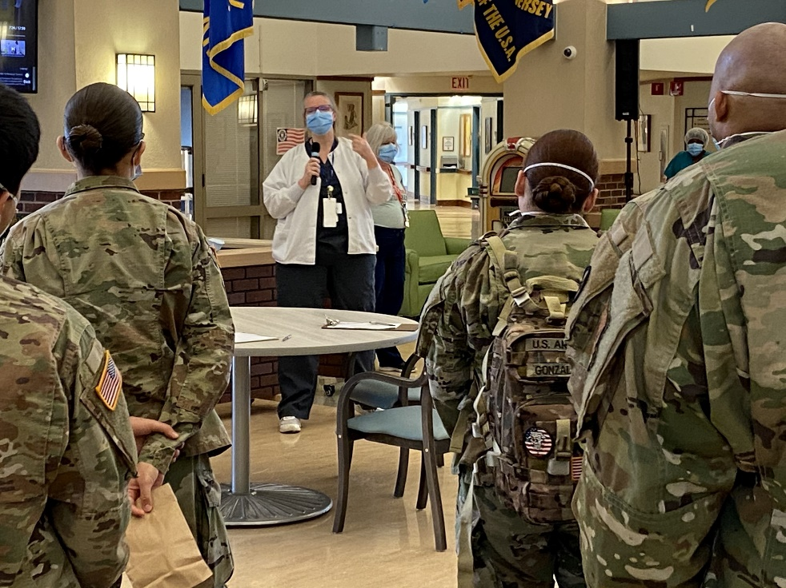
Left: Lisa Bailey RN, BSN, MS and Right: Lesley Pyjas RN, MSN

Lesley Pyjas RN, MSN, Nurse Educator/BVAC Liaison/Veterans Health Education Coordinator from the New Jersey VA and Lisa Bailey RN, BSN, MS a Certified Infection Control Nurse from the North Port VA teamed up in providing support to the NJ State Veterans home as part of the VA’s 4th mission to support the nation in the time of crisis. This nurse duo provided intensive infection control support and evidence-based use of Personal Protective Equipment (PPS) training to the staff providing care to the Veterans in the state nursing home. Ms. Bailey focused on the content of the education program. In addition, Ms. Bailey outlined the strategy for testing staff and patients, contact tracing, and for management of those testing positive, creating at least 20 new standard operating procedure documents. Ms. Bailey also provided mentoring for a new hired infection control nurse. Ms. Pyjas delivered much of the training. In addition, Ms. Pyjas focused training on team-based care, stress management, and self-care to support the staff. This team building and self-care support was essential as it occurred during the peak of the Covid infection in the New Jersey area. The staff providing care at the New Jersey Veterans Home consisted of existing staff, members of the national guard and VA deployed staff.

Ms. Pyjas and Ms. Bailey joined the staff at the NJ nursing home as team members. Through tracking and procedure enhancement group training and self-care support Ms. Pyjas and Ms. Bailey did what nurses do the best; Educate and Empower. The staff reported feeling safer and more confident in performing care.

