Year of the Nurse Story – CGVAMC – Asheville, NC
VA Nurse Leads VHA’s First Virtual Reality Distraction Therapy Program to Improve Patient Outcomes and Patient Experience
In 2017, Caitlin Rawlins, BSN, RN; a new graduate nurse at the Charles George VA Medical Center (CGVAMC) in Asheville, NC; started working on a virtual reality (VR) program. VR is a complementary therapy that uses immersive distraction to optimize health, improve pain management, promote relaxation, and improve Veteran experience. To impact pain, stress, anxiety, boredom, and negative behaviors, VR draws attention into a different “reality,” leaving less attention to process incoming pain signals and distracting attention away from adverse sensation or emotion. In addition, the option of VR therapy empowers staff to use a non-opioid, whole health approach to better care for our Veterans.
Due to Ms. Rawlins’ hard work, in July 2018, CGVAMC became the first VA medical center to utilize virtual reality distraction therapy. Ms. Rawlins initiated a Virtual Reality quality improvement pilot study with post-operative patients as part of the Enhanced Recovery After Surgery Protocol. Ms. Rawlins’ project has continued to flourish thanks to support from her nurse manager and CGVAMC leadership, as well as through the hard work of the nurses Ms. Rawlins has trained to use VR with Veterans.
Since project initiation, approximately 130 Veterans have completed VR sessions. Outcomes demonstrate that 70% of Veterans who have participated reported a reduction in pain during or after a VR session (78.6% of those with reductions in acute pain and 62.5% of those with reductions in chronic pain), 87% felt calm and relaxed following a session, and 96% were relieved of their boredom. In addition, VR has helped improve patient experience, 89% of patients found the experience useful, 93% enjoyed the experience, and 95% stated they would recommend VR distraction therapy to their fellow veterans.
The program gained international recognition in April 2019 when Ms. Rawlins was awarded the Pathway Award, sponsored by Cerner, at the 2019 Pathway to Excellence Conference. With the $25,000 given to CGVAMC as part of the award, Ms. Rawlins was able to expand the program to the CGVAMC Community Living Center to be used with patients in short-term rehabilitation, long-term care, and hospice, as well as to all other inpatient acute areas. Ms. Rawlins will present the culmination of this work at the 2020 Pathway to Excellence conference.
Ms. Rawlins was also selected to present her work with VR at Demo Day of the 2019 VHA Innovation Experience held at the National Press Club in Washington, D.C. This presentation, and her dedication to innovation and helping Veterans, led to further funding and expansion of the project. This year she received $55,000 via “Spark, Seed, Spread” funding from the VHA Innovators Network (iNET). This funding has enabled her to spread the project to CGVAMC’s outpatient oncology infusion clinic, pre-operative holding area, post-anesthesia care unit, and outpatient mental health clinic as well as funding the initiation of new VR programs at 4 others VAMCs in Biloxi, Memphis, Reno, and Little Rock. Ms. Rawlins will be presenting CGVAMC’s data and patient outcomes, as well as data collected at all 4 spread sites, once again at the 2020 Demo Day in October 2020.

Ms. Rawlins has plans for continued growth of the program for Veterans who have chronic pain and kinesiophobia and for post-operative orthopedic patients who would perform exercises in VR and receive feedback on meeting exercise goals at home following hospital discharge.
Virtual Reality Therapy is an innovative technology and part of the future of healthcare. VR will play a significant role in research and care delivery while providing an avenue for alternative and adjunct therapies. The possibilities are truly limitless. Ms. Rawlins hopes to continue to build the VR program by expanding to other areas of CGVAMC and other facilities to further improve Veteran experience, outcomes, and quality of care.
Examples of Patients Using VR
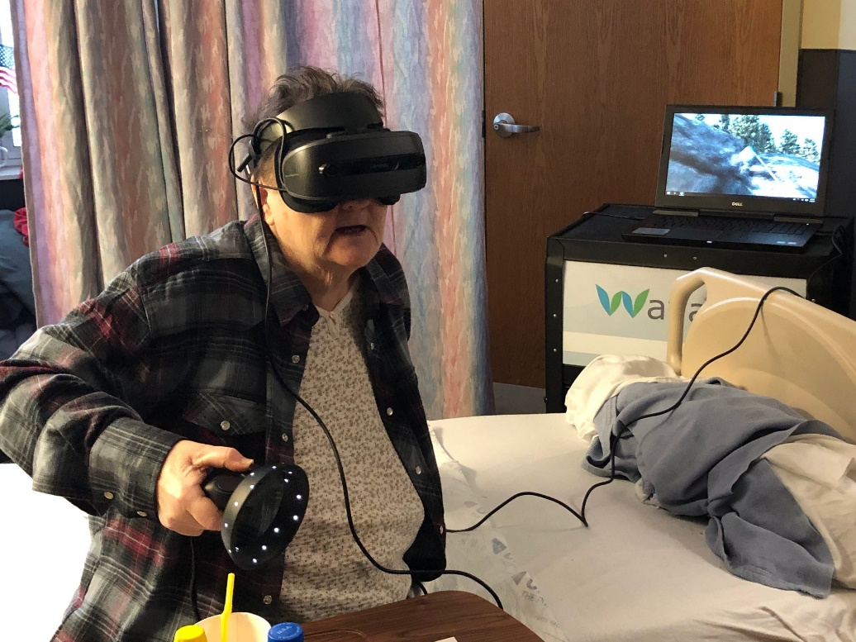
Ms. Rogers is a wheelchair-bound army veteran at the CGVAMC Community Living Center (CLC). She has significant chronic pain and several mental health diagnoses. Prior to becoming a CLC resident, Ms. Rogers was a volunteer at the local nature center, helping to care for injured animals.
Now imagine Ms. Rogers “walking” through a forest, “climbing” rocks, “wading” through wildflowers, or even “walking” along a beach. This is precisely what happened when she experienced Virtual Reality Distraction Therapy. Ms. Rogers lit up with excitement and walked through the forest, spotting deer, butterflies, and listening to the birds chirping. Not only was Ms. Rogers thrilled with her experience, but so were the nurses caring for her, as they watched her smile with wonderment. This experience enabled Ms. Rogers to be temporarily distracted from her pain, immobility, and boredom, while having a positive impact on her quality of life.
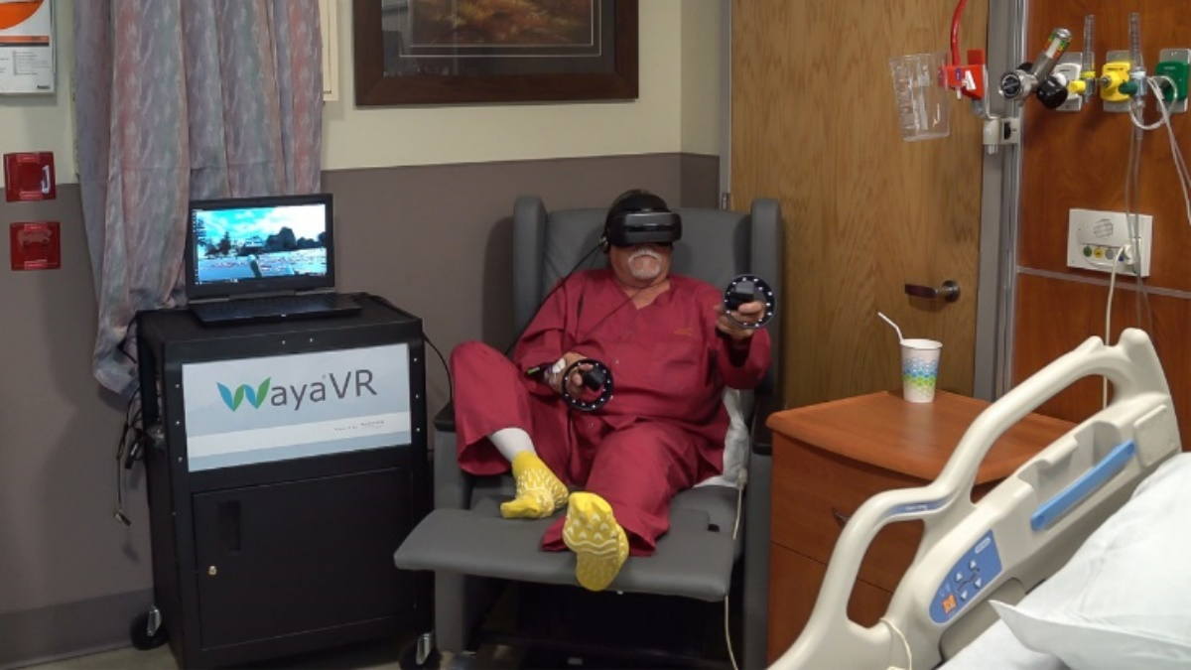
"It takes your mind off your time in the hospital, and it takes your mind off your pain." Gregg Richter, Army Veteran
Mr. Richter was one of the first Veterans to utilize VR at CGVAMC. VR was used as a distraction therapy to aid in pain management and helped to decrease opioid use following a left total knee arthroscopy in 07/2018.

