Roseburg VA Health Care System Implements Whole Health

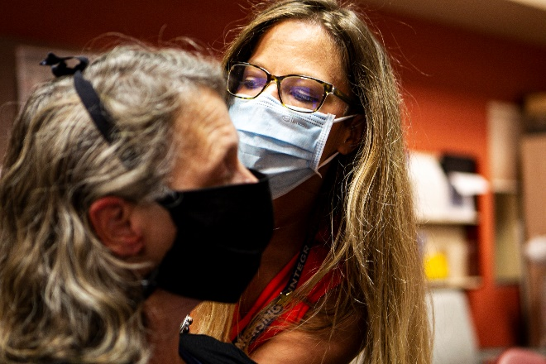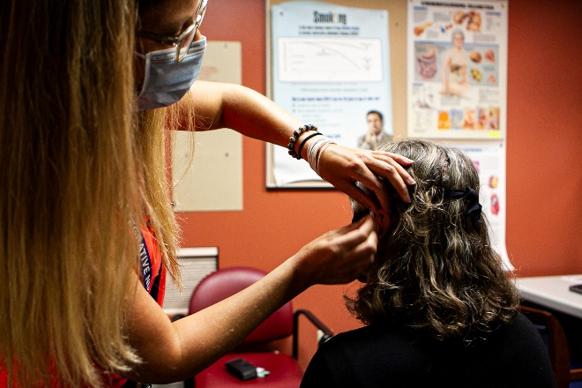
Dr. Erickson demonstrates Battlefield Acupuncture (BFA) on Dr. Galbraith

Roseburg VA Health Care System (RVAHCS) is a new wave site for Whole Health System implementation. As the Associate Director for Patient Care Services, Barbara Galbraith, PhD, MBA, RN engaged in the positive energy by leading this exciting cultural transformation of VHA from a system of “sick care” to one of “wellness”. RVAHCS’ early Whole Health journey included the exploration of the option of RNs providing Battlefield Acupuncture to Veterans to assist in the reduction of opioid usage for chronic pain.
Dr. Galbraith facilitated the ability for RNs to provide Battlefield Acupuncture (BFA) in their pain management tool kit while focusing on safe and quality care for Veterans. Dr. Galbraith and the Roseburg Whole Health & Wellness Team worked with the Oregon state licensing board to ensure nurses were cleared to provide BFA while employed in federal service and on federal property. Dr. Galbraith led Nursing in the BFA initiative by receiving BFA training. She continues to provide BFA to Veterans.
One of the most compiling stories of pain relief involved a paraplegic who wanted to return to mountain climbing, but he was having too much upper body pain. After the first treatment, the pain was reduced enough for the Veteran to return to mountain climbing. To date, more than 1135 BFA encounters have taken place at RVAHCS, contributing to a non-pharmacologic, nurse led response to pain management. The RVAHCS provides BFA at all five sites; Roseburg VA Medical Center, Eugene Health Care Clinic, North Bend Clinic, Brookings Clinic, and Eugene Downtown Clinic.
Dr. Galbraith is proud to be the executive sponsor for the RVAHCS Whole Health & Wellness Department. The RVAHCS Whole Health & Wellness team provides these services: Battlefield Acupuncture, MOVE! Weight Management Phone Lifestyle Coaching, Mindfulness Meditation Group Class, Guided Meditation for Sleep, Pain, & Anxiety Group Class, Taking Charge of My Life and Health Group Class, Whole Health Phone Coaching, Chronic Pain Management Group, Tai Chi, Yoga and Qigong.
Dr Galbraith is a Veteran herself having retired from the US Army Reserve Nurse Corps with the rank of Major after 21 years of service.

