Wound Ostomy Nurse Practitioners on the COVID Frontlines
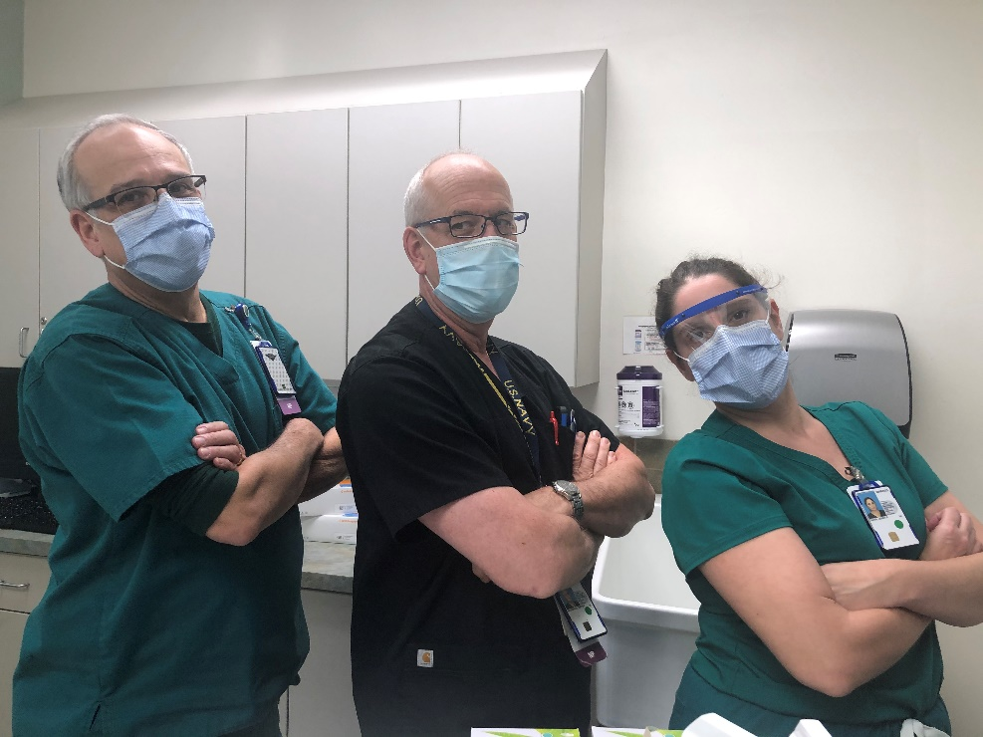
Pictured: Kippen Jacobson MSN, RN, NP-C, CWOCN, CFCN; Miguel Rosado MSN, RN and NP-C; Jenny Davis MSN, RN, CNP-BC, CWON

Here at South Texas Veterans Health Care System, we have a small group of nurse practitioners who are board certified in wound, ostomy, and continence nursing. These nurses are passionate and committed and wasted no time tackling the unique problems related to COVID19 infections head on. They round daily on the inpatient wards, providing wound care, nursing support, and education. They run a busy clinic caring for our veterans as outpatients. These nurses study and implement evidence from scientific literature, and they are constantly on the quest for the best products, processes, and evidence in order to ensure our Veterans get the best care possible. They work hard to solve unique problems and STVHCS is one of the best because of them.

