Nurse Recruiter Laura Sarmiento

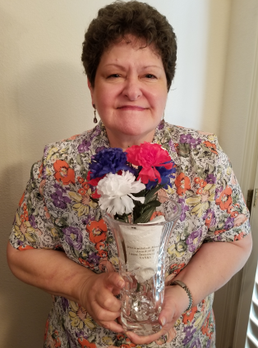
Laura Sarmiento, RN, MSN, CHCR is the first El Paso VA HCS Nurse Recruiter, and she has been in this position since June 2008. She is a proud Army Veteran. Her experience has facilitated many applicants better understanding with the VA application processes. Laura provides excellent customer service with internal and external applicants making their experiences a positive one. People have a choice where they work. Making applicants first contact a positive experience leads to better engagement and better outcomes beneficial to the El Paso VA.

Laura has recruited numerous RNs, APRNs, LVNs and CRNAs over those twelve years including three Nurse Executives. Laura works diligently with all applicants providing guidance with their necessary on-boarding documents and preparing their NPSB packets. She participates in military sponsored hiring fairs to facilitate military dependents applying for VA jobs. She also is an active participant with the various local Nursing School Career fairs.
Laura is the Chair of the El Paso VA HCS Nursing Recruitment and Retention Committee. This committee has RNs and LVN representatives from all the El Paso/Las Cruces VA Facilities. Committee members bring up recommendations that facilitate a better work environment for everyone. They also prepare for annual Nurses Week activities for all facilities. Laura is also the El Paso VA Daisy Award Co-Chair.
Laura Sarmiento, RN, MSN, CHCR El Paso VA HCS Nurse Recruiter

Laura was honored in 2018 by the VA Nurse Recruiter Association (VANRA) with the “Distinguished Member Award” for her leadership in Nurse Recruiting. Laura precepts and mentors new Nurse Recruiters, and she is a Certified Health Care Recruiter (CHCR) since 2014. She has been an active participant in National Association of Health Care Recruiters (NAHCR) as well as National Nurse Recruiters, and she applies current trends in recruiting to her Nurse Recruiter role daily.

Seth Godin’s thought on Recruiting is, “Recruiting is the act of finding the very best person for a job and persuading them to stop doing what they are doing and come join you.”

