Behind the Scenes: Helping Nurses to Be More Successful and Veterans to Get Better Care
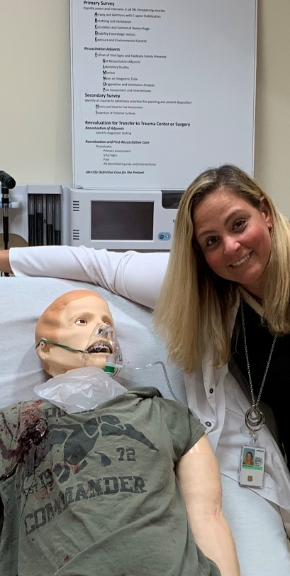
By Helen Mills, MSN, RN-C, LXMO, AHI
The role of nurse educator is often misunderstood. As no one can be an expert in all things, an educator is not required to know all, but to discover and share the necessary components for success. This means constantly learning, asking questions, researching, interviewing, and keeping an open mind. It means contacting subject matter experts for guidance and instruction, corroborating the content with research on evidence-based practice, developing creative ways to disseminate the information, and delivering it to the masses. It is a complicated process that appears to be very simple.
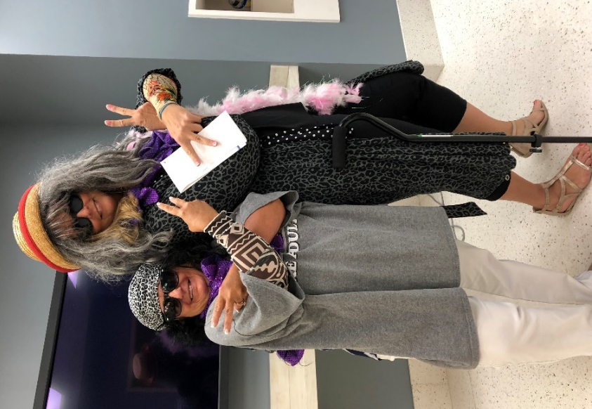
I am very fortunate to work at SimLEARN National Simulation Center. Prior to Covid, nurses from all over the country came to our facility to “experience” education through our simulated hospital environment. The high-fidelity manikins are very lifelike. They talk, blink, breathe – they even sweat! The classes are fun, interactive, and exciting. We dress up, laugh a lot, and learn in a way that is undoubtedly memorable and impactful. People constantly tell me that they wish they could work here, where we get to “play” all day. I agree that it is an amazing place to be.
Left: Sherri Boisvert; Right: Helen Mills
What people don’t know is that each class takes roughly eight months to create and an entire team is involved in the process. The Project Manager coordinates everything behind the scenes. Educators work with content experts to develop the content and create the course materials. Curriculum developers design educational objectives for classes and ensure that accreditation standards are met. Our Simulation Technicians set up the equipment, test it, and help to run it during the classes. The Video Producer handles any videography needed. Simulation Educators orchestrate the delivery of classes. Education Technicians help to prepare the materials for learners and assist with travel arrangements. These are just a few of the team members and a simplified explanation of their roles. It really takes a village to create excellence.
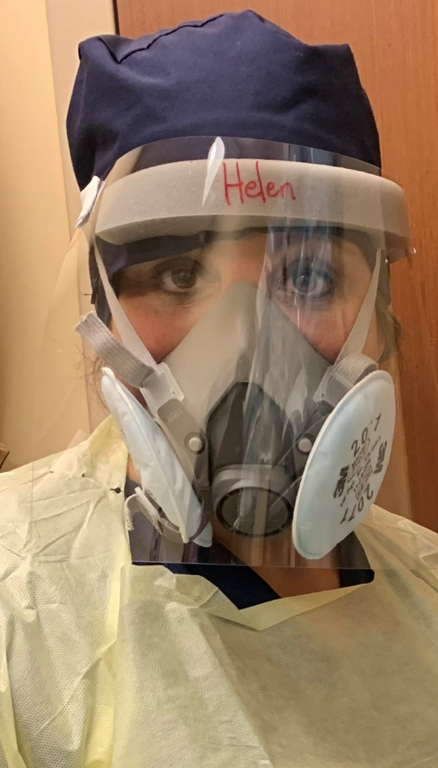
With the recent ban on travel, COVID has proven to be a game-changer. Now, our team is working diligently to convert our classes to distance-education formats. It is very challenging to create virtual education that is still exciting and interactive. Therefore, in addition to virtual classes, we have developed “SimLEARN To-Go” options, that will allow educators at VA facilities everywhere to use the materials at their own facilities to bring the highest level of simulation education to their home sites. All of this is available at no cost.
Working from a distance, I don’t get to see firsthand how my work directly impacts others. I do get to hear about the way that this education has transformed the way that nurses view things. I hear about the excitement of bringing simulation to the hospitals. I hear how eye-opening experiences help our nurses to see things in new ways. I hear how our Veterans receive better care from more confident health care professionals. Knowing this, I have to say that I am very proud to be a part of this organization and certainly proud to be a nurse educator.

