New Orleans NP Carolyn Storck
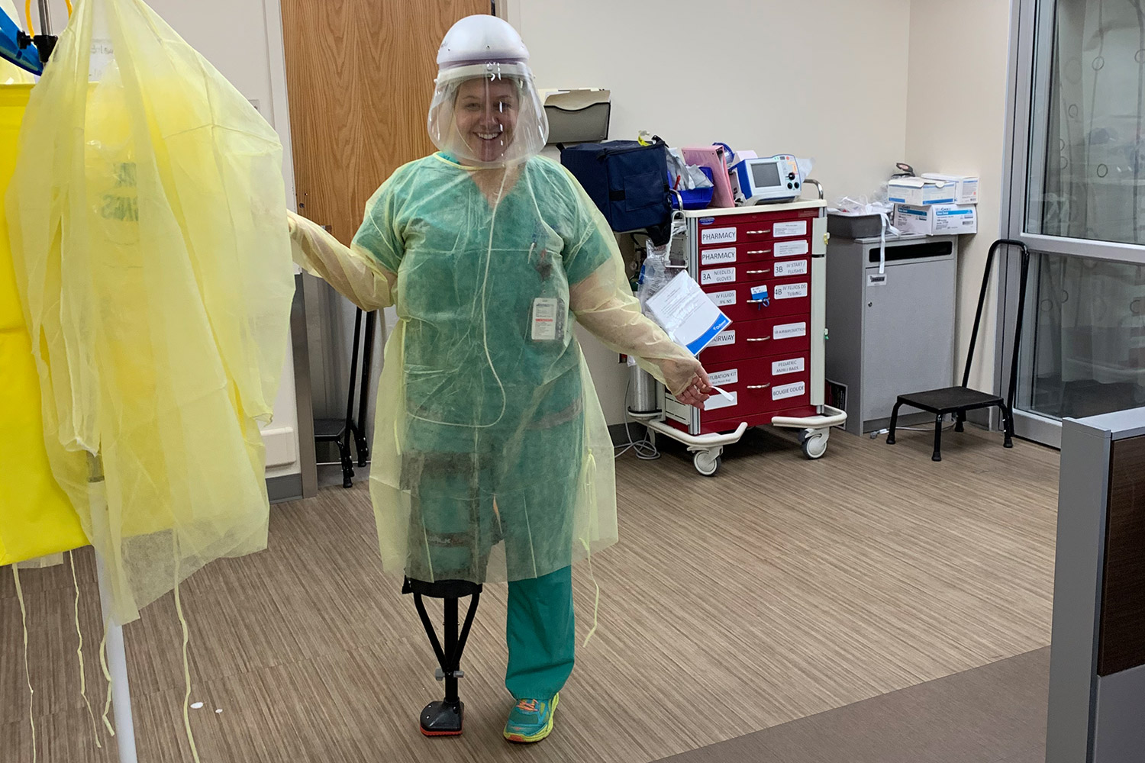
New Orleans emergency nurse practitioner Carolyn Storck demonstrated remarkable commitment to our nations Veterans during the COVID-19 outbreak in New Orleans which resulted in a call for “all hands on deck.” Well in this case, Ms. Storck put one foot and one hand-free crutch on the deck to help care for Veterans. Ms. Storck came back to work in the Emergency Department (ED) just two weeks after an achilles tendon repair surgery. She was able to resume working 12-hour shifts by using a hands-free crutch. She reports “I felt an obligation to my colleagues. If a gap in the shift or something needs to be done, I think all of us have the mindset of you step up and you do it. You’ve got to take care of people." While Ms. Storck makes this look easy in the photo, she describes the experience as scary and intimidating. She reports that she works with “amazing” colleagues that come together to maintain a high quality of care for Veterans. She is proud of her NOLA ED team.
Ms. Storck is a Navy Veteran herself and worked in Military Treatment Facilities (MTF) as a civilian before joining the VA in October 2017. Ms. Storck has a BSN from the University of Michigan and an MSN from Marymount University. She has been a Nurse Practitioner for 20 years.

