Long Beach VAMC Certified Nursing Assistant (CNA) Janice Turner

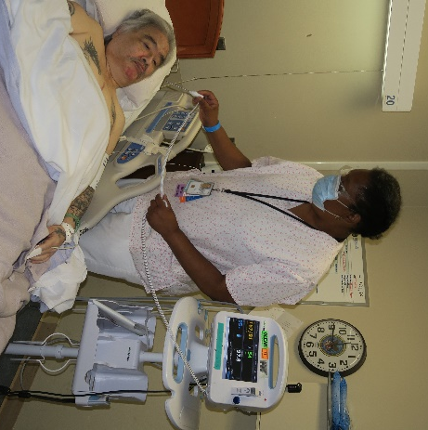
Ms. Turner has dedicated her entire career of 35 years to the VA. She currently works in the Community Living Center (CLC) in Long Beach where she is a vital member of a team that addressed the complex needs for patients with dementia and cognitive impairment. Ms. Turner provides valuable perspective as she attends weekly interdisciplinary team meetings. She is an active participant of the Bright Spots program which shifts the “way of thinking” for unit improvement and the Falls Prevention program. Ms. Turner is skilled in develop rapport with patients and their families in all aspect of the excellent care she delivers and consistently displays ICARE values.

Cheryl Bunico

