VA Video Connect – Virtual Nursing
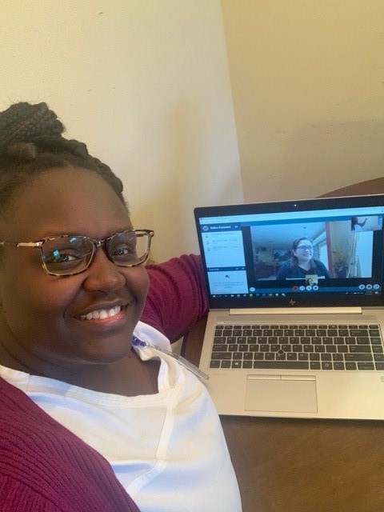
Yvonna Beckford, LPN & Christine Tipanero, RN Care Manager (pictured in the computer)

What is Virtual Nursing?
Can we really provide quality nursing over the web? The answer is yes! Yvonna Beckford, LPN demonstrates this daily. She works on a patient aligned care team (PACT) with the James A. Haley VA located in Tampa, FL. She provides high-quality care, establishes rapport, delivers effective feedback and educates through VA Video Connect (VVC).
Prior to a Veteran’s Primary Care appointment, Ms. Beckford prepares the patient for the video conference during her PACT Pre-Planning calls. On the day of the appointment, she talks through each step with the Veteran until they are seen on the VVC video. After this is accomplished, she proceeds with the nurse screen. She educates the Veteran on the proper technique to obtain their blood pressure on a VA issued monitor. The Veteran completes a successful return demonstration during the visit.
Ms. Beckford provides education on medications, hypertension and diabetes management. Veterans discuss and present lifestyle factors and health interventions they complete on a daily basis with Ms. Beckford in the comfort of their homes. VVC use allows the Veteran’s PACT team to get a better understanding of the Veteran’s environment and tailors their healthcare needs uniquely to each Veteran. Ms. Beckford facilitates building a deeper relationship and trust with each Veteran.

