VA Infusion Clinic CELEBRATES Ms. Bale!
By: Nerissa Mackie, RN, CRNI

Ms. Bale is one of our Veterans that comes in for her routine infusion at the Infusion Clinic. We got to know her not just medically but on a personal level. She is very goal oriented and determined to finish what she started, like her bachelor’s degree in Marine Biology.
With the COVID pandemic affecting her school and the world needing to adjust with the new norm, Ms. Bale didn’t stop. She continued her scheduled infusion therapy while she did her school online. A brave Veteran and an inspiration to us.
As she finished, we found out that her graduation ceremony was canceled, therefore the Infusion team decided to celebrate her dedication and accomplishments.
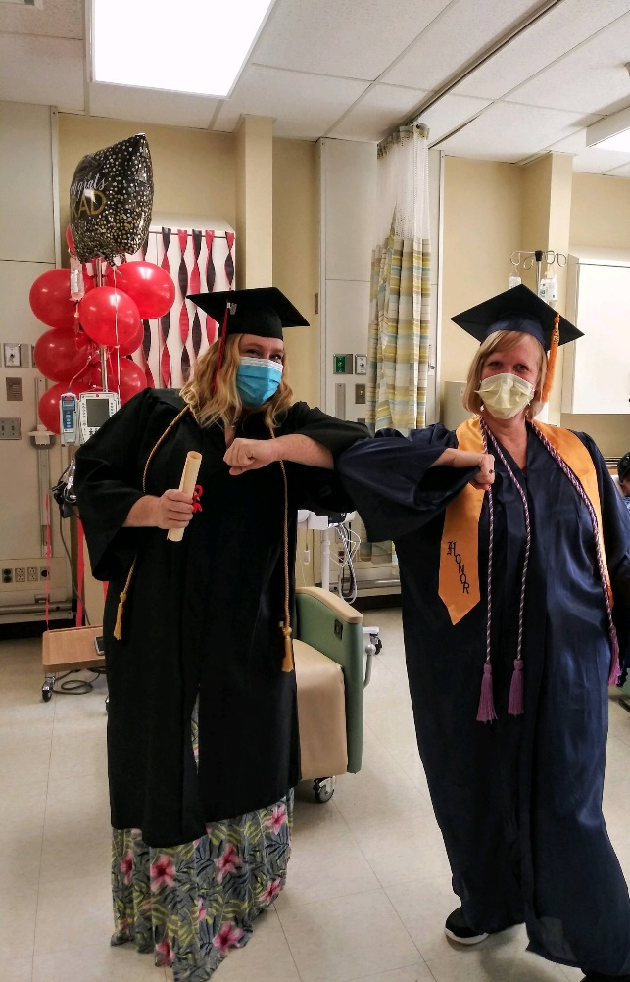
The team surprised Ms. Bale with a Graduation Ceremony. From the playing of pomp and circumstance, presentation of the diploma, flowers and a reception; The newly graduate stood proud in her cap and gown as she shed tears of joy.
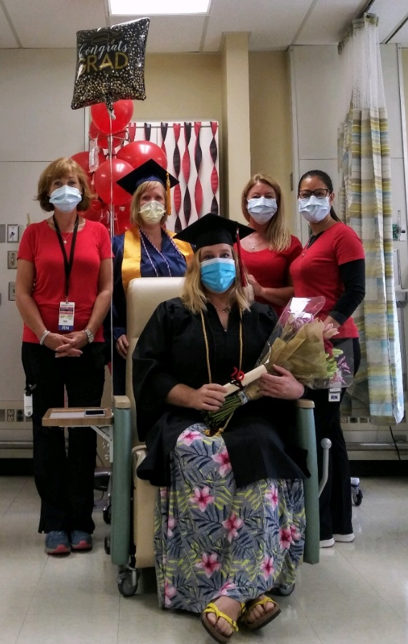
It’s a memory of joy that will be treasured for a lifetime.
Congratulations
Ms. Bale!
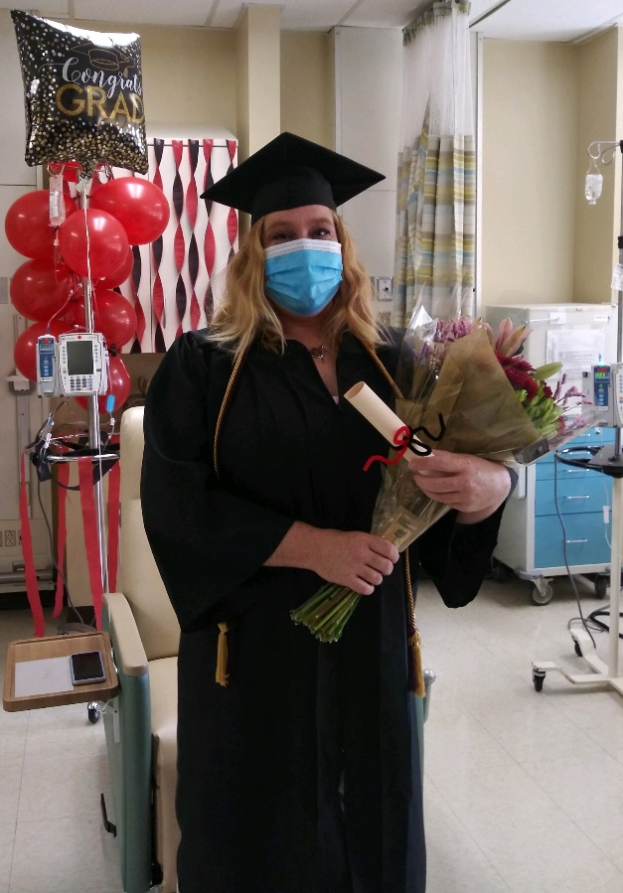
We CELEBRATE YOU!

r
Ms. Bales and the Infusion Team from Left to Right Phyllis Sink, Dawn Justice, Melanie Thompson, and Nerissa Mackie
Ms. Bales and Dawn Justice representing the Dean of Ceremony

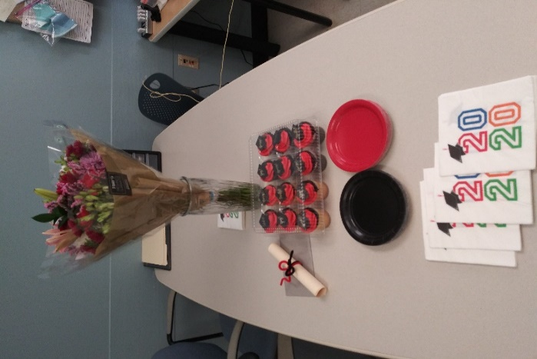
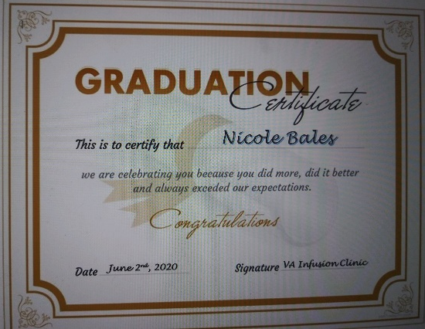

Ms. Nicole Bales – Veteran that goes to VA Infusion Clinic, Graduated BS in Marine Biology

