Sandra Walker-Halliman, MSN, RN, VHA-CM, Ralph H. Johnson VA Medical Center Charleston, SC
Reusable Medical Equipment Coordinator/Sterile Processing Services Educator
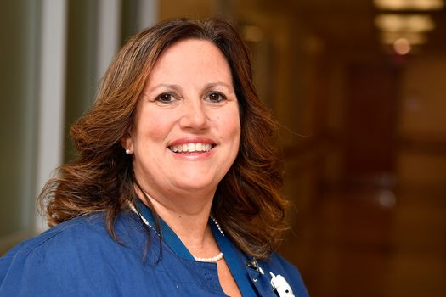

“I chose to work at the VA because it is the highest honor to care for those who have served our country and sacrificed in order to defend our freedoms.”
Ms. Walker-Halliman is an independent change agent and an innovative motivator who has worked for Ralph H. Johnson VA Medical Center 3.5 years. She provides mentorship on staff development, preceptorship, evidence-based practices, reusable medical equipment, sterile processing, and facility wide programs. Her leadership/mentorship relates to complex healthcare, project management, and program development which enhance VHA policy at all levels. She collaborates with interprofessional teams to develop and implement training programs which support High Reliability Organizations, regulatory policies. and continuous education for those who care for a diverse patient population of Veterans. She is also highly involved in community outreach in the local areas ensuring indigent populations are educated on health, self-care, life saving techniques, First-Aid, and Safety setting a standard of service. Ms. Walker-Halliman steps up for key leadership roles in her professional practice.
Ms. Walker-Halliman is the South Carolina Trauma Nursing Core Course Director and works in conjunction with VHA National Sim Learn to bring the Trauma Nursing Core course to Emergency Room and Intensive Care Unit nurses within RHJVAMC. The virtual training collaborative enrolled 28 sites including Puerto Rico in the offering. She facilitates, instructs, and leads the course within RHJ. Her course graduates posted a 100% pass rate, Ms. Wlaker-Halliman was noted for being an “excellent instructor” by her students in the online feedback rating scale by Emergency Nurses Association. She was acknowledged for her TNCC Program by SimLEARN National TNCC Director “for all of your efforts in making this such a wonderful program”. In the ONS Annual Report this same program was recognized for having 406 virtual students and awarding a grand total of 15, 318 continuing education credits.

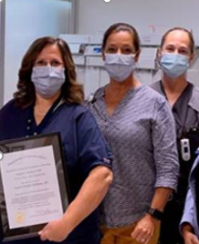
Left to Right (Sandra Walker-Halliman RME Coordinator/SPS Educator,
Sherri Jones Chief Nurse Operative Services, and Justice Pride Sterile Processing Services Chief)

