Nancy Webb, LPN and Veteran

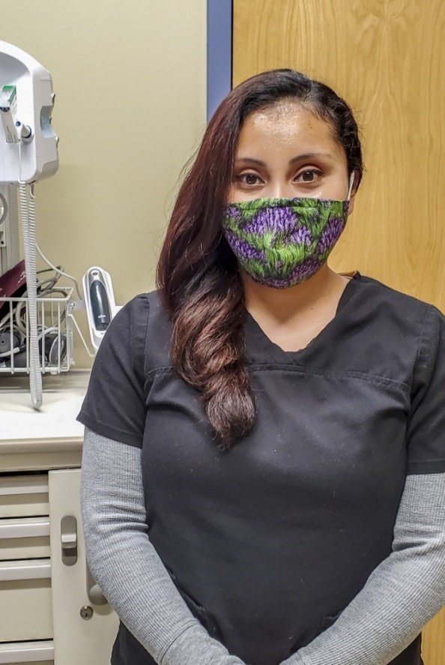
“I have always had a tremendous respect for anyone who has served in the military. As a nurse, one of my primary responsibilities is to advocate for the patient and their family.” So says Nancy Webb, a licensed practical nurse with the Roseburg VA Health Care System in Brookings, Oregon. The Gold Beach native has been with the Roseburg VA for nine years and has a personal connection to the services she and her team provide for Veterans – though she herself is a Veteran, her husband also served in uniform. Her focus on providing high-quality care extends to all her patients and opens some doors for Veterans needing services outside an exam room, she said. The RVAHCS has five facilities across southern Oregon and serves four Oregon counties and Del Norte County in Northern California. (Official VA Courtesy Photo/Released).

Nancy Webb, LPN

Photo by T. T. Parish

Roseburg VA Health Care System

