What Does Caring Look Like?

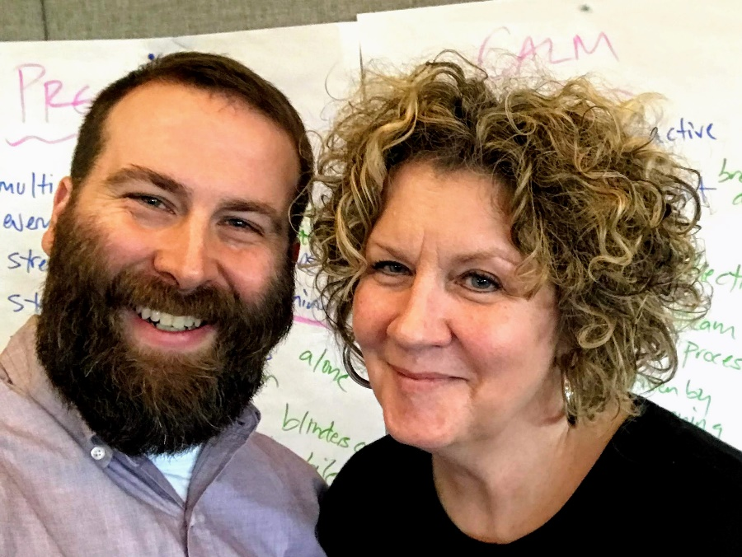

Karen Nordahl, MSN, RN, CCCTM
Adam White, BSN, RN

As nurses, how do we promote and sustain caring and compassion in healthcare? How
do we create healthy work environments that support self-care and well-being so care of others can be optimized? How do we maintain connection with meaning and joy in an industry that serves more complicated individuals every year...with fewer resources...amid seemingly never-ending change?

At the Portland VA, we use Relationship Based Care (RBC) principles and weave them into our Whole Health (WH) model to equip nurses for a journey of self-awareness, fulfillment, skill-building and enhanced relationships.

As COVID created new obstacles for nurses, we developed the WH Wellness & Coping Workshop, offering sessions to small groups of staff. To improve access, we also created a virtual WH Toolkit, with simple tools and practices, that are facilitated virtually and customized as needed.

While this work is critical for the well-being of nurses, we are also deeply moved by the translation of these practices to actual patient moments.

Adam applied some of these in his care for a patient who was terminating curative treatment and pursuing comfort care. While waiting for the hospice referral, the Veteran became increasingly anxious and impulsive. Adam used the relationship practices of Attuning, Wondering, Following and Holding (Koloroutis & Trout, 2012) to build a deeper connection with his patient. As the Veteran began to express how alone, afraid, and overwhelmed he was, his stress response intensified. With his permission, Adam guided him through the mindfulness practice of anchoring which reconnected him to a moment in his life when he had experienced a deep sense of peace, connection, and love. A calmness enveloped the Veteran and he described the moment as “one of the most wonderful experiences of my life…thank you for helping me get back there, to the river near my childhood home...helping me remember that my life has been beautiful. I know that it’s time to go, and that’s OK.”

Moments like these remind us why we were drawn to healthcare in the first place; they reinforce our calling and the honor of being a nurse. Nurses are invited behind the curtain, into our patients’ lives, to share in the most powerful of human experiences…but also to linger there, to build relationship in ways others don’t have the opportunity to do. But we can’t do that with an empty cup. Empowered by the intentional work of WH/RBC, we learn that self-care is the very foundation of our potential as caregivers and should be held as a non-negotiable aspect of our roles. We see that self-care allows us to be present, to nurture others as we nurture ourselves, to connect with our patients as fellow people...to practice becoming more Whole. By seeking balance and managing our energy, we better sustain our own wellness and can offer our best selves to our patients, colleagues, and profession.

