2020 YEAR OF THE NURSE: A FOCUS ON HOLISTIC NURSING
CIH Highlight—Virtual Reality (VR) Nurse Highlight:
Caitlin Rawlins, BSN, RN
Floor Nurse—5West
WNC VA HCS Virtual Reality Project Lead

Q: Why did you become a nurse?
A: I actually spent all of my childhood wanting to be a surgeon and started my first undergraduate degree in pre-med. However, I then switched my major and ended up graduating with a BA in painting and art history. It wasn't until 2010, when I was contemplating what else I would like to do for a
career that I looked into nursing. I wasn’t sure I’d like it—I wanted to be a surgeon or an artist!—but after starting and completing my first nursing degree in 2010 as a LPN, I knew I had entered the right profession. I loved that holism is an integral part of nursing. I loved the rapport I built with my patients—I felt I could finally help others in the way I was meant to. As someone who has also always had an interest in alternative and complementary medicine, I found nursing to be a great career avenue to both utilize the benefits of Western medicine and the benefits of complementary & integrative medicine. Now, nine years later, my career path in nursing has taken me to places I had never dreamt of and working with my favorite patient population. It’s one of the best decisions I’ve ever made.

Q: How is holistic nursing relevant now more than ever?
A: Whenever we, as humans, react to something—particularly something hard, tragic, or life-altering—it doesn’t just affect one aspect of our being, it affects the whole person. Now, as we traverse such a unprecedented challenge to our well-being— individually, as a country, and as a world community — it is more important than ever to treat those we care for in a holistic manner. This is already an integral piece of nursing; we heal their physical bodies, but also pay attention to what ails them emotionally, mentally, and spiritually. Tragedy and hardship can be isolating, especially during a pandemic. Nurses and other frontline workers are in a unique position to offer guidance, healing, kind and encouraging words, hope, and we can only do so by looking at the WHOLE to determine their individual needs.

Virtual Reality (VR) is a CIH modality that was first introduced to veterans at Charles George VAMC in July 2018.
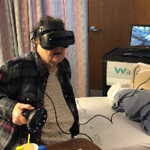
VR describes a three-dimensional, computer-generated environment that can be interacted with through use of a VR headset. VR uses immersive distraction to optimize health through positive effects on Veteran experience, improvements in pain management, decreased levels of stress and/or anxiety, alleviation of boredom, or
positive effects on behavior. To impact pain, stress, and/or anxiety, VR draws attention into a different “reality,” leaving less attention to process incoming pain signals and distracting attention away from adverse sensation or emotion. The primary VR software currently being used at CGVAMC includes a choice from 8-10 VR environment

options ranging from relaxing nature environments and mindful breathing exercises, to exciting snowball shooting and boxing, even the
Nancy Rogers, wheelchair- bound Army Veteran “walks” through the woods in VR for the first time

opportunity to visit a virtual art museum or paint their own masterpiece.

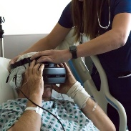
This modality was first brought to Caitlin Rawlins’ attention in the fall of 2017 by Dr. Nagy, orthopedic surgeon, who had heard about it from a colleague in Boone, to be used as an adjunct therapy for patients receiving the Enhanced Recovery After Surgery (ERAS) Protocol. After researching the modality and its indications, Ms. Rawlins presented this idea to Practice Council and Nursing Leadership, receiving unanimous approval for the project and funding as a nurse-driven intervention. Utilizing the first two VR
units purchased, a pilot study was completed on 5West with primarily post-surgical patients aiming to aid in pain management, decrease opioid use, decrease stress/anxiety, and improve veteran experience. This pilot study would not have happened without the constant support of CGVAMC leadership, Nurse executives Dave Przestrzelski and Linda Bugg, CNS Natalie Parce, and 5West Nurse Manager

Caitlin Rawlins Assisting
J.R. Compton, First Veteran to Use VR at CGVAMC
Amanda Graves. Data for this quality improvement pilot was collected via an embedded, voluntary survey. Initial data was very positive for the project, incentivizing Ms. Rawlins

to apply for more funding, through the ANCC Pathway Award and the VHA Innovators Network (iNET), to expand the project/modality to other areas of CGVAMC.
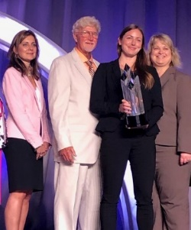
In April 2019, the project received the ANCC Pathway Award and $25,000 sponsored by Cerner at the 2019
ANCC Pathway to Excellence Conference. Further funding allowed this pilot to expand to the Community Living Center, hospice, and to all other inpatient areas at CGVAMC. Growing this program was aided in no small way by both CIH nurses at CGVAMC, Annette Racer and Lynn Mennin. Both nurses have helped to increase awareness of the VR program and have graciously added VR to the repertoire of CIH therapies offered in all inpatient areas and the CLC/Hospice.

In Fall 2019, Ms. Rawlins’ proposal to iNET was accepted for Spread funding and gained further support and publicity at the 2019 iNET Demo day held at the National Press Club in Washington, D.C. Through Spread funding. Ms. Rawlins
Caitlin Rawlins, BSN, RN receiving
2019 ANCC Pathway Award, pictured (from left to right) with Melissa Solito, MBA, BSN, RN-BC, CNO for Cerner,
Dave Przestrzelski, MS, RN, ADPCS/ Chief Nurse Executive CGVAMC,
Steph Young, WNC VA Healthcare System Director

has been able to expand the use of VR to the post-anesthesia care unit, day surgery, outpatient mental health, as well as spread the program to four other VAMCs in Biloxi, Reno, Memphis, and Little Rock. To increase use of VR at CGVAMC, Ms. Rawlins has trained over 30 licensed staff members to use VR and continues to train others as interest increases.
Separate from the primary VR software being used, Ms. Rawlins has also aided in getting a new VR software program and hardware from AppliedVR donated to CGVAMC for a pilot in the Oncology Infusion Clinic . This will be a year –long pilot to aid those veterans with pain, stress, anxiety, and boredom.
Ms. Rawlins continues to consult with other VAMCs to aid in the creation of other VR programs across the country, including Reno, Denver, Durham, Salt Lake City, Dallas, and Los Angeles. Additional grant funding has also been applied for to expand VR and its indications for use at CGVAMC to the Veteran’s Integrative Pain Management Clinic for those with chronic pain and kinesiophobia, to the CLC to be integrated with Heartmath/Biofeedback, as well as VR for the employee “Recharge Rooms” being piloted.
VR technology changes rapidly and has unlimited possibilities for application. Due to exceptional teamwork, collaboration, and unwavering support, CGVAMC/WNC VA HCS remains at the forefront of VR in the VHA—bringing the newest and most effective technology to our veterans.
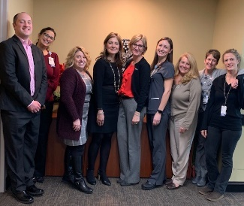

ANCC/Cerner Site Visit Dec 2019, pictured: Dr. Joe Morgan, Wellovate President, Amanda Graves, 5W NM, Linda Bugg, Chief Nurse of Operations &
Acute Care, Melissa Solito, Cerner CNO, Rebecca Graystone, ANCC VP of
Magnet/Pathway to Excellence, Caitlin Rawlins, VR Project Lead, Natalie Parce, CNS,
Annette Racer, CIH RN, Lynn Mennin, CIH RN

"I didn't even notice my pain while I was doing the VR.
It also helped relax me and made it easier for me to talk about things."
- Veteran Response to VR session, September 2019

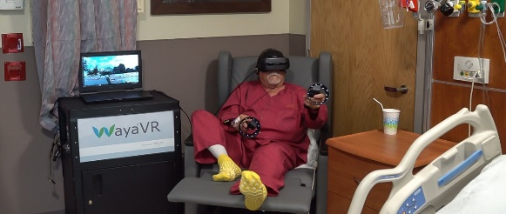
As part of WLOS feature, Army Veteran Gregg Richter photographed experiencing VR for the first time after Total Knee Arthroplasty in July 2018

Nurse Executive Highlight:
Linda Bugg, MSN, RN – Chief Nurse, Operations & Acute Care

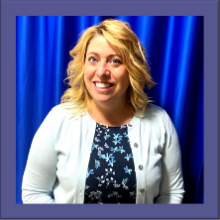
Q: Why did you become a nurse?
A: Both of my parents worked in the health care field. My siblings and I were told, as long as I can remember to find a job in health care because you will always have work. All five of us listened. My father was a retail Pharmacist and I always believed that would be my chosen field. After working in a medical facility as a pharmacy technician, I had the opportunity to witness
the hands on care, advocacy and interactions between nursing, providers and patients/families and knew this was where I belonged. I followed in my mother’s footsteps and became a nurse and started my dream job after graduation in a Medical Surgical ICU. The rest is history!

Q: How is holistic nursing relevant now more than ever?
A: Holistic nursing has taken on a new meaning due to our current pandemic situation. I have always believed that work/life balance and self- care are paramount to staying healthy, now more than ever we have to take the time to recharge to be able to provide care for others. We have grown our Integrative Health Program tremendously in the last two
years. Many nursing staff provide healing touch and during this time of COVID-19, human touch and interaction is needed more
than anything.

