Excellence at VA Maine: Deborah Milbury, NA

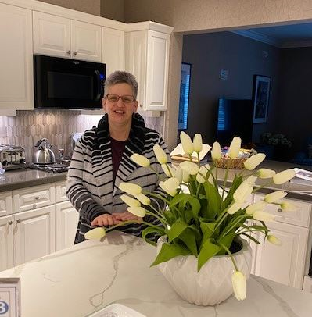

Deborah Milbury, NA

Deb is a nursing assistant at VA Maine and she exemplifies the ICARE values in everything she does. She is reliable, positive and ready to work with a smile.

Deb consistently goes out of her way to ensure Veterans have everything they need, no matter how small the request, and tries to ensure Veterans feel comfortable and at home. She has cooked many special meals, and on one occasion a Veteran needed clothing to wear for his 100th birthday celebration; Deb was able to locate an outfit for the Veteran for this special event. It is this attention to detail and compassion which makes Deb an excellent Nursing Assistant.

Her teamwork, respect, and collegiality are evident in her willingness to work with the healthcare team. She assists with food, clothing and often kneels to eye level when communicating. During her time in the Hospice neighborhood, Deb proved time and time again she is dedicated to our Veterans. On more than one occasion, Deb has been heard saying “I am here to care of ALL of the Veterans”. Deb has demonstrated this through flexibility, and willingness to float to any neighborhood with need.

Deb’s integrity and commitment to helping others are truly in her DNA. She is a genuine advocate of others and personally develops plans of care to achieve this. She is respectful of others and is an excellent advocate.

We would like to thank Deb for all she does for our Veterans.

