Innovation Aroma Therapy Masks for Staff

Nurses play a vital role in providing health services, both within our organization and the private sector. Nurses devote their lives caring for others; and with over 80,000 nurses throughout the VA health system, we are the largest employer of nurses in the Nation. In addition, the COVID-19 pandemic has brought to light once again, the importance and dedication of the of nurses throughout all healthcare systems. It is no surprise that the World Health Organization, declared 2020, the Year of the Nurse.

The VHA Innovation Ecosystem and Office of Nursing Services are proud to celebrate the Year of the Nurse by highlighting a unique nurse-led innovation each month for the remainder of 2020. This month, we introduce Nicholee Froese, RN, from the Albany Stratton VA Medical Center and her complimentary care for pre-operative anxiety program.

Like many nurses, Nicholee’s decision to become a nurse was in direct response to a personal event. She experienced hospice care with both of her grandfathers in short succession. “I knew from experiencing the care they and we received from hospice nurses that I needed to change the course of my life’s work. I had been doing educational research and spent most of my days in front of a computer screen with little face to face interaction. Nursing has allowed me to engage my heart AND mind in providing the same kind of care that once transformed my life,” Nicholee on her decision to go into the field. Flash-forward 13 years, Nicholee began her VA as a nurse in the Specialty Clinics and quickly found her way into her current position as a Surgical Care Coordinator.

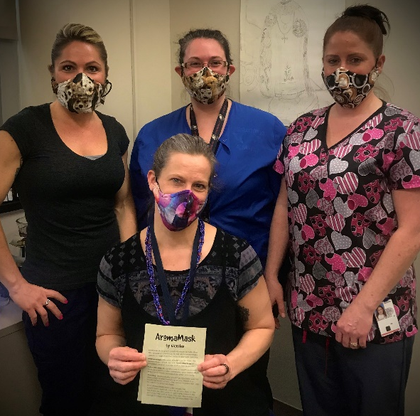
It was there, she found inspiration for her innovative program. “In my work as a Surgical Coordinator, I frequently encounter patients who are afflicted by almost paralyzing anxiety about their upcoming surgery. For a multitude of reasons, patients are terrified of pain, loss of control, surgical failure, unsuccessful recovery and death. Most patients were not aware of and do not have access to other tools to help them cope with their pre-operative anxiety,” said Nicholee. Her idea was to provide complimentary therapies to surgical patients to help relieve pre-operative anxiety. Her program gives patients the opportunity to wear an Elequil Aromatab on the day of surgery for Aromatherapy, listen to music, and wear a weighted blanket for the soothing effects of deep touch pressure, before, during, and after their procedures.

Then the pandemic hit, Nicholee explains, “We suddenly had almost no surgical patients to receive any services we might provide”. All successful innovators know when they need to pivot from their initial idea and that’s what Nicholee did. “I was witnessing an unprecedented level of anxiety among my fellow staff members, especially nurses. We are superheroes when it comes to taking care of others but tend to neglect taking care of ourselves,” said Nicholee. Today, if you hear CODE LAVENDER at the Albany Stratton VAMC, you can thank Nicholee. The program’s new name, Code Lavender, provides employees with Elequil Aromatabs to use during their shifts. Nicholee is sewing AromaMasks for fellow employees to incorporate self-care into the new Universal Masking guidelines and will soon establish several temporary Serenity Spots, with weighted blankets and comfortable chairs, for staff in current underutilized spaces, like visitor lounges. “Together we will emerge stronger, healthier, and more connected to each other and to our mission and purpose of serving our nation’s Veterans,” said Nicholee.
Photo Caption: RNs Samantha Gugenberger, Melissa Sequinot, Theresa Wells, & Nicholee Froese wearing AromaMasks.

