New York Harbor VAMC Nursing Assistant (NA) Pamela Brown

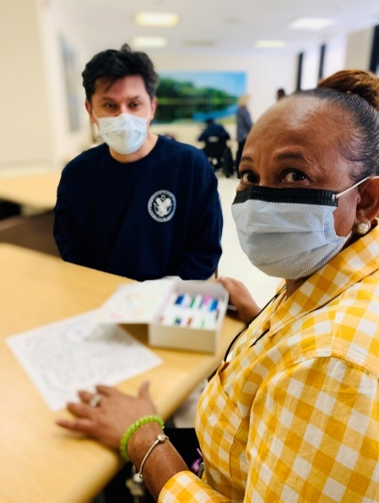
Pamela Brown NA always has a smile and kind word for Veterans and staff. She is a team player, and numerous Veteran patients have commented how upbeat and pleasant Ms. Brown is when performing her duties. She serves as a role model to create a collegial working environment and looks for opportunities to promote positive working relationships and good customer satisfaction. She is skilled in assisting in psychiatric emergencies both on the unit and throughout the hospital by providing a calming and supportive environment. She is knowledgeable regarding HIPAA and ensures that patient privacy is maintained. Ms. Brown skillfully observes patients alerting the nursing staff of any changes in behavior or demeanor requiring additional assessment or care. She collaborates with the Social Workers, Registered Nurses, her peers and the Interdisciplinary Treatment Team to provide outstanding care and contributes to discharge planning as appropriate. Ms. Brown supports the VHA Mental Health and unit-based performance improvement initiatives such as Post Discharge Engagement (PDE) and efficient patient throughput from the ER to 17 North. She assists the RN with the admission process, timely discharges, and the Fall Prevention program. She has a quest for knowledge and looks for training opportunities. Ms. Brown’s goal is to increase her knowledge base, and to look for promotional opportunities within the Mental Health Care Line. In fact, she recently became a Health Care Technician. Ms. Brown is a very valued member of the 17 North team and a true asset to VA NYHHS’ community.
Pamela Brown partnering in care with Veteran patient Marcelo Arbelaez

Cynthia Caroselli, RN, PhD, Associate Director for Patient Services

