Pittsburgh VAMC Nursing Assistant (NA) Alicia Waters VISN 4
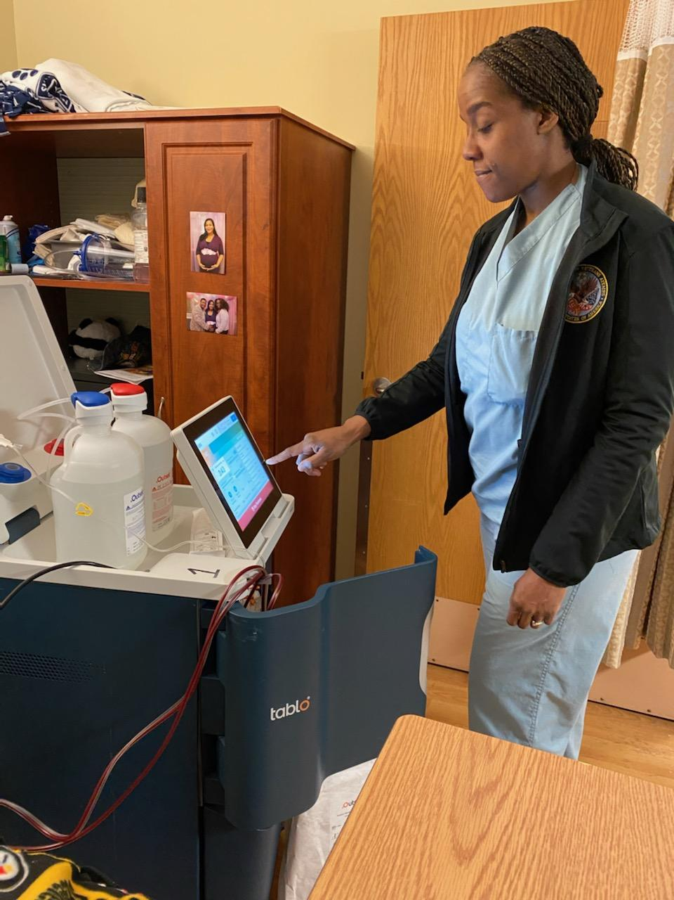
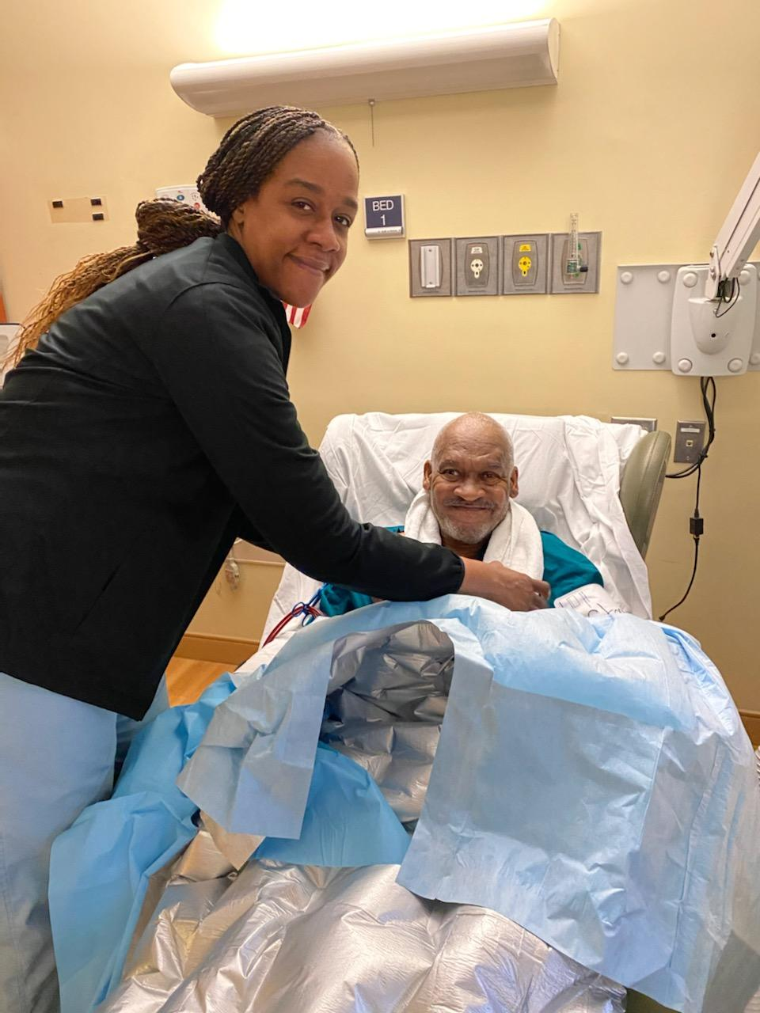

Alicia Waters with patient William Standard, veteran in 1S VA Pittsburgh HCS

Ms. Waters works as an NA in one of the largest units in the Pittsburgh Community Living Center. (CLC). Ms Waters has an outstanding work ethic, demonstrating creativity, a caring attitude and organizational skills. Ms. Waters was nominated by her peers as “Employee of the Month” for 3 consecutive months in 2018 for her dedication and commitment to both the veterans she serves and her co-workers. She identifies the needs of the patients and families without prompting. She constantly treats all patients with respect and delivers the compassion and care needed. For example, while working with a patient with Parkinson’s, Ms. Waters noticed that the resident was having difficulty feeding himself. Ms. Waters brought
this to the interdisciplinary teams’ attention, following through with making sure a consult was
entered for OT to obtain weighted utensils allowing the resident to maintain dignity and
independence benefits. Ms. Waters is a unit champion of the Safe Patient Handling Movement and ensures all staff are adequately educated to all equipment on the unit. To achieve this goal, Mr. Waters created "Safety Month" in which all staff are observed on the proper use of the equipment. She gives feedback and guidance when needed. She not only focuses on the equipment; she also monitors staff's body mechanics. As results of her dedication, 1S has maintained a 100% compliance.

