Katelyn Erickson, DNP, RN-BC, CRRN, Employee Whole Health Coordinator

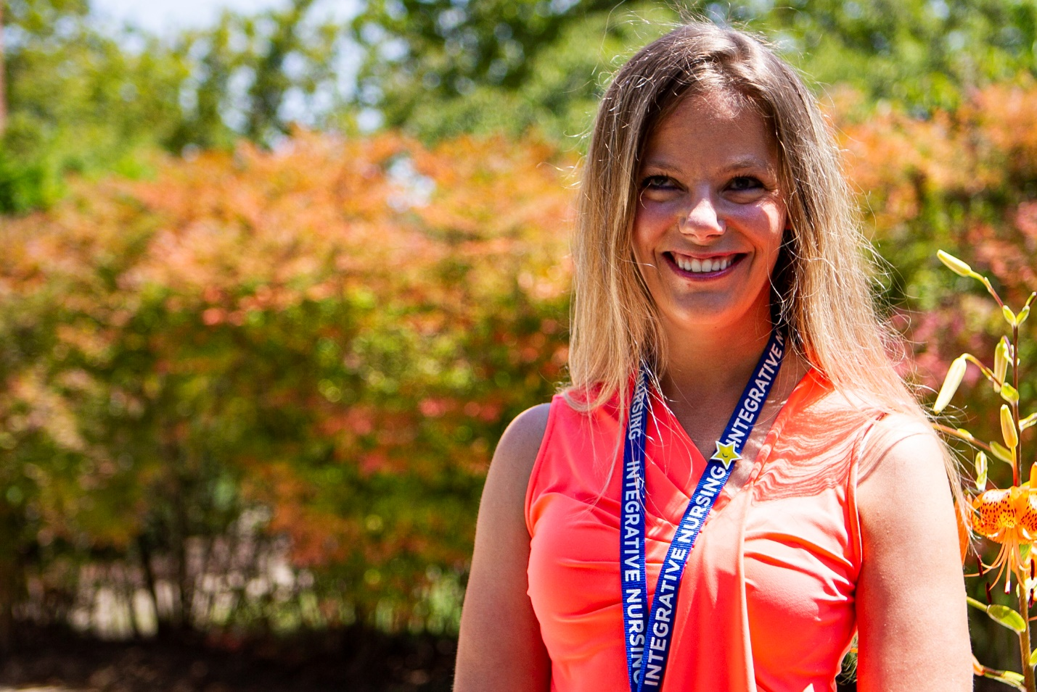
Katelyn Erickson
The World Health Organization’s designated Year of the Nurse and Midwife 2020 has evolved to become a historical era of health care, including the Nursing Profession - the largest sector of the health care workforce across the nation and globally. The time is now to prioritize the wellbeing and self-care of nurses, and beyond. As Whole Health Systems transformation continues to expand across the VHA, Employee Whole Health is a critical component within the Whole Health System Designation Framework. Roseburg VA Health Care System (RVAHCS) is facility offering nursing – driven wellbeing programs for employees across the system, including rural coastal clinics. Katelyn Erickson, DNP, RN-BC, CRRN, Integrative Health & Healing Clinician serves as the Employee Whole Health Coordinator and works among a dedicated team to facilitate programs and services that work toward fostering an organizational culture of health and wellness.
Dr. Erickson is passionate about driving this paradigm shift in health care. Nurses are well-positioned to advance the health and healing of individuals, communities, and organizations. Nursing burnout and compassion fatigue are systems issues requiring cultural change and individualized moral agency for self-care. To support these efforts, she has developed innovative approaches to expand holistic nursing self-care modalities onto virtual platforms and phone appointments. RVAHCS nurses across the system have access to drop into virtual Yoga Nidra, Guided Imagery Meditation, and Mindful Moments in the Workplace as examples using Microsoft Teams and VANTS. Whole Health Coaching phone appointments support the development and implementation of a personalized wellbeing plan, while the nine-week MOVEmployee Whole Health program offered through the VA Virtual Medical Center (www.vavmc.com) supports small group accountability through Whole Health nutrition and physical activity goals, transforming to an empowered sustainable lifestyle. Academic affiliate health professional Residents are supported through virtual evidence-based practice didactic Whole Health discussions addressing self-care and building resiliency into their clinical practice and personal lives.
Nurses work to drive health promotion and healing beyond the walls of health systems. Through an engaged local community partnership, Roseburg VA Health Care System was designated a Blue Zones Project approved worksite in July 2020. Blue Zones Project (https://oregon.bluezonesproject.com/) is an evidence-based community wellbeing initiative driving socioeconomic population health, longevity, health policy change across sectors in fifty U.S. communities, including Roseburg, Oregon.
When nurses recognize their ownership of their Whole-Person (body-mind-spirit) health and healing, this is the heart of Nursing practice that drives greater Presence and Compassion in Veteran-Centered Whole Health Care. Holistic, Whole Health Nursing has implications for improved safety, quality, and care experience of our Veterans. With nursing self-care, we build resiliency to continue to carry Florence Nightingale’s legacy, embodying the art and science of Nursing practice, and Celebrate the Year of the Nurse 2020, and move toward a Whole Health System of Care. “I couldn’t be more grateful for this doing very purposeful and meaningful work to drive health and healing systems transformation, while celebrating Nursing, during these especially trying times”.
The COVID-19 pandemic has shifted operations of health care delivery resulting in heightened levels of stress and uncertainty across health care settings. RVAHCS Executive Leadership recognized the priority to support the health care workforce, and thereby generated a COVID-19 Incident Command Employee Support workgroup. Dr. Erickson and her wellness colleagues designed and implemented services by listening to the voices of employees across the system through a needs assessment survey. Site-wide daily announcements for mindful movement stretch breaks, inspirational wellness quotes, mindfulness practice in meetings, telework wellness strategies, stress management, and tobacco cessation services have generated high receptivity. Employees from across sites, departments, and roles have joined forces, stepping up to support COVID-19 screening efforts. This Incident Command Employee Support workgroup is grateful to have partnered with the local Veteran Canteen Services and Executive Leadership Team to offer employee appreciation packs and vouchers in gratitude for their response to help with COVID-19 health safety and prevention.

