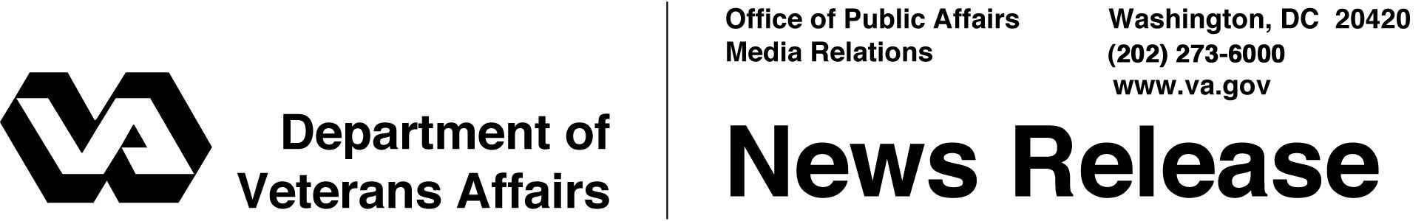

FOR IMMEDIATE RELEASE
December 22, 2003

Veterans Receive Cost-Of-Living Increase In Benefits
WASHINGTON – The Department of Veterans Affairs (VA) is including a 2.1 percent increase in the disability benefit payments that millions of veterans and dependents will receive at the end of December.
President Bush authorized an increase matching the increase in Social Security rates by signing into law the Veterans Compensation Cost-of-Living Adjustment Act of 2003.
"These benefits are a reflection of countless sacrifices ranging from peacetime injuries to wartime service," Secretary of Veterans Affairs Anthony J. Principi said. "Cost-of-living increases for veterans and their survivors ensure strong programs that keep pace with their needs."
The new rates apply to benefits earned in December. VA benefit payments routinely are made at the beginning of the month following the one in which they are earned, but with the New Year's Day holiday, checks or direct deposits will generally be received on Dec. 31.
Those receiving the increase include 2.5 million veterans awarded compensation for disabilities sustained or made worse during their military service, as well as 347,000 wartime veterans who are totally disabled from civilian-life causes and who receive a pension under an income-based program.
The increase also will go to 337,000 spouses, children and parents of veterans who died in service or from a service-connected condition, and another 231,000 who are served by an income-based program for survivors of wartime veterans.
Most veterans and survivors will receive their increased VA compensation or pension through direct deposit, which VA encourages because of its speed and security.

# # #

