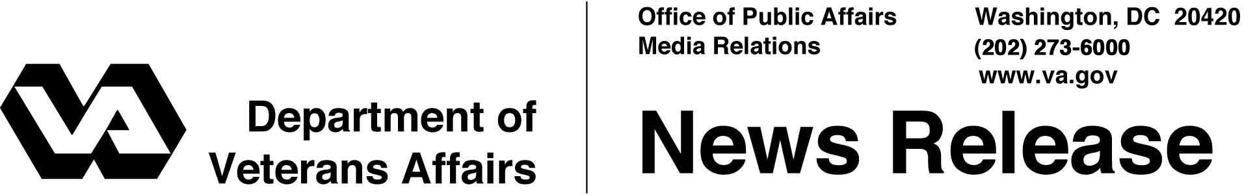

FOR IMMEDIATE RELEASE
January 24, 2012

Veterans and Beneficiaries Receive 2012 Cost of Living Adjustment
Information Available On-Line for E-Benefits Enrollees
WASHINGTON – Veterans, their families, and survivors receiving benefits from the Department of Veterans Affairs saw a 3.6 percent increase in their compensation and pension benefits beginning January 1.
“Veterans, their families and their survivors are entitled to benefits that keep pace with the cost of living,” said Secretary of Veterans Affairs Eric K. Shinseki. “VA is also using the latest technology to provide Veterans and their families with access to current information about their benefits.”
The new compensation rates will range from $127 monthly for a disability rated at 10 percent to $2,769 monthly for 100 percent. The cost of living adjustments (COLAs) also apply to disability and death pension recipients, survivors receiving Dependency and Indemnity Compensation, disabled Veterans receiving automobile and clothing allowances, and other benefits. The full rates are available on the Internet at www.vba.va.gov/bln/21/Rates/#BM01.
Under federal law, COLAs for VA’s compensation and pension rates are the same percentage as for Social Security benefits. The last COLA for VA benefits was in 2008 when the last Social Security increase occurred.
“Veterans receiving VA disability and pension payments can now check their new 2012 COLA increase online,” said Under Secretary for Benefits Allison A. Hickey. “I encourage all Veterans, their dependents and survivors to sign up for eBenefits, VA’s popular website that recently crossed the one million mark in registrations.”
In close collaboration, the Department of Defense (DoD) and VA jointly developed the eBenefits portal (https://www.ebenefits.va.gov) as a single secure point of access for online benefit information and tools to perform multiple self-service functions, such as checking monthly benefit rates, filing a claim, or checking its status.
Veterans may enroll in eBenefits and obtain a Premium account by verifying their identity in-person at the nearest regional office or online depending on their status, or calling VA’s toll free number at 1-800-827-1000.
Servicemembers may also enroll in eBenefits using their Common Access Card at any time during their military service, or before they leave during their Transition Assistance Program briefings.
VA is enhancing its online eBenefits services with newer features such as online selection of Veterans organizations or other advocates to represent applicants for benefits where representation is desired.
Another new feature automates messages sent to Veterans and Servicemembers to notify them of benefits that they may be eligible to receive based on recent life events, such as military separation or marriage.
The site also continues to consolidate access to other VA and DoD systems through the portal, recently incorporating a gateway to vocational rehabilitation benefits under VA’s VetSuccess program.
Web access to information and benefits management tools for Servicemembers, Veterans and their families is part of VA and DoD’s lifetime engagement strategy from an individual’s entry into the military through the twilight years in civilian life as a Veteran.
VA provides non-taxable compensation and pension benefits to over four million Veterans, family members, and survivors. Disability compensation is a non-taxable monetary benefit paid to Veterans who are disabled as a result of an injury or illness that was incurred or aggravated during active military service.
For more information about VA benefits or new payment rates, visit www.vba.va.gov or call 1-800-827-1000.

# # #

