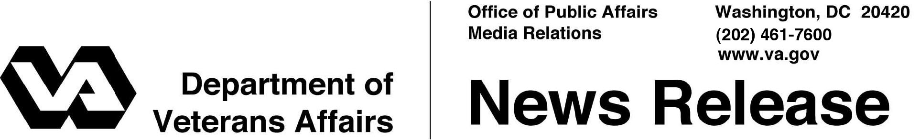

FOR IMMEDIATE RELEASE
February 1, 2012

VA Caregivers Support Line Celebrates First Anniversary
Program Received More Than 25,000 Calls in First Year
WASHINGTON – On Feb. 1, the Department of Veterans Affairs (VA) will mark the one-year anniversary of the toll-free National VA Caregiver Support Line, 1-855-260-3274. The support line’s dedicated staff has helped more than 25,000 Veterans, family members and Caregivers connect to resources and receive access to services they have earned.
“VA recognizes the importance of Caregivers to our Veterans’ health and well being. We also recognize the sacrifices the daily care of their beloved Veteran requires,” said VA Secretary Eric K. Shinseki. “It is the care and commitment of Caregivers that allows Veterans with chronic illnesses or severe injuries to remain in the homes they defended, surrounded by the loved ones they hold dear. I am proud we have been able to help so many Caregivers in this first year of the support line’s operation.”
Since the program began, the Caregiver Support Line has received more than 25,000 calls and email queries through VA’s main page www.va.gov. Local Caregiver Support Coordinators at each VA medical center have responded to more than 8,000 referrals. Callers to the support line are spouses, children, other family members and friends of Veterans as well as Veterans themselves. Caregiver Support Line responders listen to the callers and assess how best to offer support, appropriate direction, and connection to needed resources.
Responders serve as a resource for Caregivers by providing guidance, education on VA programs and benefits, information on community resources and emotional support through brief supportive counseling, if needed. The support line responders can also connect callers to VA’s other support lines such as the VA Veteran Crisis Line (1-800-273-8255) and Coaching Into Care Line (1-888-823-7458) when these lines better meet the callers needs.

-More-

Caregiver Support Line 2/2/2/2

“Caregivers play such a critical role in the lives of our nation’s Veterans, often at great cost to themselves. VA recognizes this sacrifice and the Caregiver Support Line is just one way we seek to support Caregivers,” said Deborah Amdur, VA’s Chief Consultant for Care Management and Social Work. “Caregivers often give so much of themselves and the social workers on the support line recognize this. They understand the challenges faced by Caregivers and are able to offer a listening ear, education and connection with needed resources.”
If a Caregiver or Veteran who calls the line needs additional guidance, a referral is made to their local Caregiver Support Coordinator, located at every VA medical center, who is the key contact for Caregivers at VA and an expert in VA and community programs available to Veterans and their Family Caregivers.
Veterans and Caregivers can reach the VA Caregiver Support Line toll free at 855-260-3274. Operating hours are Monday through Friday, 8 a.m. to 11 p.m., ET, and 10:30 a.m. to 6 p.m., ET on Saturdays. VA also features a Web page, www.caregiver.va.gov, with general information on other Caregiver support programs available through VA and the community.

# # #

