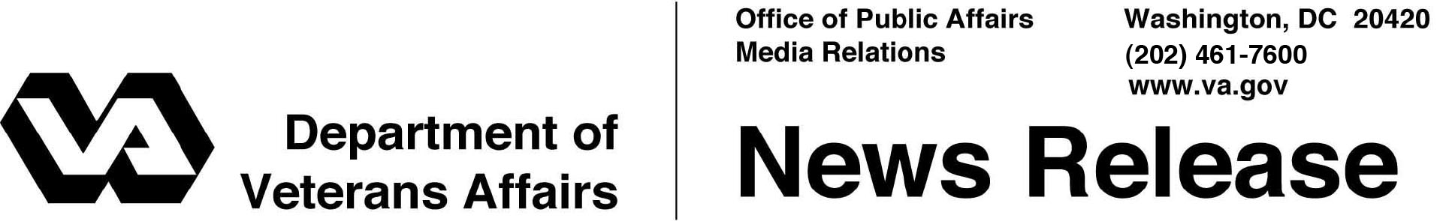

FOR IMMEDIATE RELEASE
September 20, 2012

VA Completes Over 1 Million Compensation Claims in 2012
Production at Historic Levels as Veterans Benefits Administration Transforms Claims Process

WASHINGTON – The Department of Veterans Affairs announced today that the Veterans Benefits Administration (VBA), which oversees the delivery of disability compensation and other benefits to the nation’s Veterans, processed over one million disability claims during fiscal year 2012, marking the third year in row VBA claims processors have exceeded the one million mark.
“We have made great strides, but we realize much work remains to be done to better serve Veterans,” said Undersecretary for Benefits Allison A. Hickey. “Too many Veterans still wait too long. That’s unacceptable, and that is why VA has begun implementing a paperless, digital disability claims system– a lasting solution that will transform how we operate and eliminate the claims backlog.”
In August, VA had its most productive claims processing period in its history, completing a record 107,462 claims and surpassing the previous monthly record of 103,296 set in 2010. This high level of production is accompanied by an increase in the overall accuracy of rating decisions, which has risen from 83 to 86 percent since September 2011, as determined by VA’s national quality assurance program.
While claims production is at historic highs, incoming disability claims have increased nearly 50 percent since 2008, outpacing VA’s current claims processing capacity.
“Our employees are working very hard to sustain this level of production,” said Hickey. “This is a testament to their dedication to meeting the increasing needs of our Veterans.”
VA’s goal is to process all disability claims within 125 days, at a 98 percent accuracy level, and eliminate the claims backlog in 2015.
This year, VBA is beginning a nationwide organizational transformation to increase its claims decision output by retooling procedures and deploying paperless data systems that will speed claims processing and improve quality. All 56 VBA regional offices will be operating under the new organizational model by the end of 2013.

# # #

