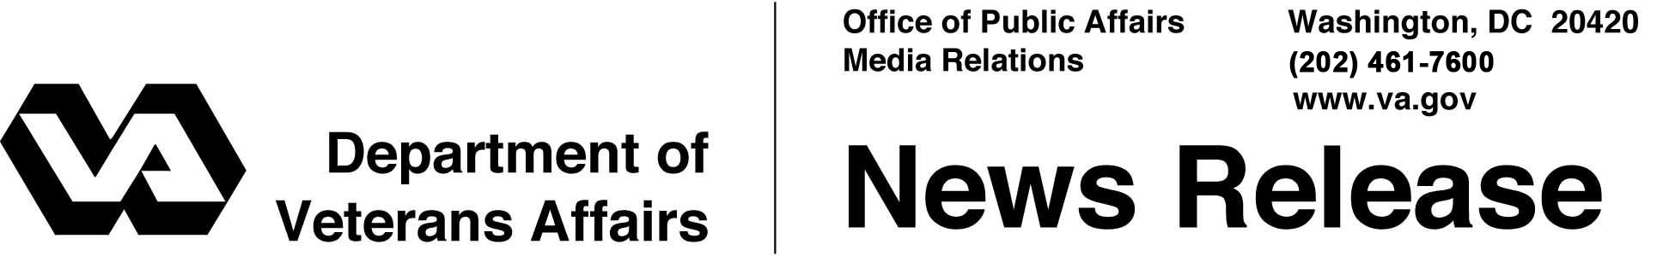

FOR IMMEDIATE RELEASE
June 30, 2011

VA Begins Implementation of Open Source Program
TIAG Selected to Build Custodial Agent

WASHINGTON – The Department of Veterans Affairs (VA) today announced that it has begun the implementation of an open source community based on its electronic health record (EHR), selecting The Informatics Applications Group (tiag) to create the Custodial Agent that will serve as the community’s central governing body. VA will contribute its current EHR, known as VistA (Veterans Integrated System Technology Architecture), to seed the open source effort.
"Our EHR is central to the quality of care we provide to Veterans,” said Secretary of Veterans Affairs Eric K. Shinseki. “As we continually advance the health care we deliver, so too must we advance the capability of EHR software. Moving to an open source model invites innovation from the public and private sectors. It is an important element of our EHR collaboration with the Department of Defense and an important part of our strategy to ensure that VA clinicians have the best tools possible, and that Veterans receive the best health care possible."
In April, VA announced its intent to establish a Custodial Agent (CA) to serve as the central governing body for an open source community. The CA will provide important communication, organizational, and administrative functions that enable community members to share information and software and to collaborate on the improvement and the use of EHR systems. tiag, an innovative technology services company, has been selected to design and launch the Custodial Agent.
“We have a tremendous opportunity to create the next generation of EHRs, which is so important to our EHR collaboration with DoD and to many current and future users of electronic health records,” said VA Chief Technology Officer Dr. Peter Levin. “In order to achieve the highest level of utility and safety, we must engage as broad a base of EHR users and developers as possible. We are working closely with tiag to design a robust Custodial Agent that enables this level of community engagement.”
VA expects the Custodial Agent to launch in August and to commence full operation in the fall. For more information, see today’s entry on VA’s VAntage Point blog (blogs.va.gov) and the Open Source EHR Custodial Agent website (www.osehrca.org).
# # #

