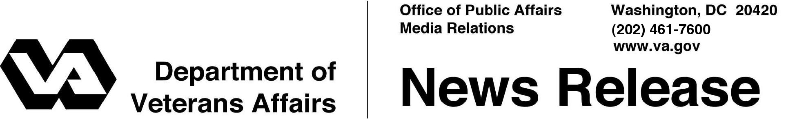

FOR IMMEDIATE RELEASE
March 22, 2012

VA Expands Medical Forms Program to Support Faster Claims Processing
WASHINGTON -- The Department of Veterans Affairs announced today the release of 68 new forms that will help speed the processing of Veterans’ disability compensation and pension claims.
“VA employees will be able to more quickly process disability claims, since disability benefits questionnaires capture important medical information needed to accurately evaluate Veterans’ claims,” said Secretary of Veterans Affairs Eric K. Shinseki. “Disability benefits questionnaires are just one of many changes VA is implementing to address the backlog of claims.”
The new forms bring to 71 the number of documents, called disability benefits questionnaires (DBQs), that guide physicians’ reports of medical findings, ensuring VA has exactly the medical information needed to make a prompt decision.
When needed to decide a disability claim for compensation or pension benefits, VA provides Veterans with free medical examinations for the purpose of gathering the necessary medical evidence.
Veterans who choose to have their private physicians complete the medical examination can now give their physicians the same form a VA provider would use. It is very important that physicians provide complete responses to all questions on the DBQs. VA cannot pay for a private physician to complete DBQs or for any costs associated with examination or testing.
“By ensuring relevant medical information can be found on one form, we will cut processing time while improving quality,” added Under Secretary for Benefits Allison A. Hickey.
-More-

VA Expands Medical Forms – 2/2/2/2

DBQ’s can be found at http://benefits.va.gov/disabilityexams. The newly released DBQs follow the initial release of three DBQs for Agent Orange-related conditions.
Veterans may file a claim online through the eBenefits web portal at https://www.ebenefits.va.gov. The Department of Defense and VA jointly developed the eBenefits portal as a single secure point of access for online benefit information and tools to perform multiple self-service functions such as checking the status of their claim.
Servicemembers may enroll in eBenefits using their Common Access Card at any time during their military service, or before they leave during their Transition Assistance Program briefings. Veterans may also enroll in eBenefits and obtain a Premium account in-person or online depending on their status.

# # #

