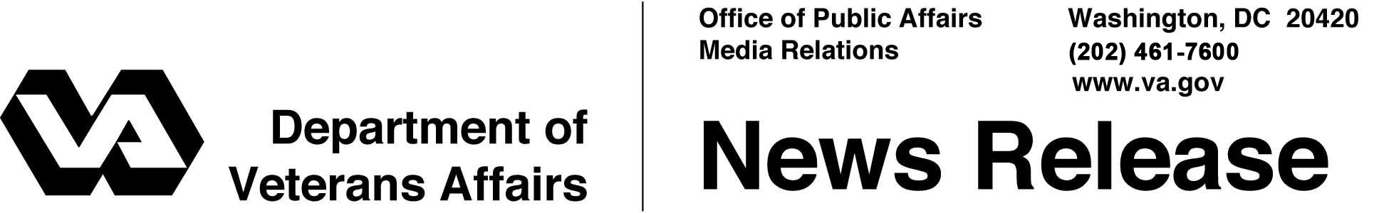
FOR IMMEDIATE RELEASE
June 22, 2012

Employers Seek Talented Veterans to Fill Administration, Business and Management Jobs Nationwide During Detroit VA for Vets Hiring Fair
Hertz Corp., Prudential Financial, Service Express Inc. and Target among Employers Hiring for Multiple Openings
WASHINGTON – The Department of Veterans Affairs continues to register public and private sector employers with open positions for its upcoming Veteran Hiring Fair, June 26-28 at Detroit’s Cobo Center. The event is free for Veterans and employers due to a sponsorship from VA for Vet (http://vaforvets.va.gov), VA’s flagship program setting new standards in Veteran employment for the public and private sectors.
“VA is pleased to be partnering with these employers to provide thousands of jobs to Veterans in Michigan and across the country. We encourage Veterans to sign up today,” said Secretary of Veterans Affairs Eric K. Shinseki.
Veterans with experience or interest in general administration and management careers are encouraged to review the positions listed by Hertz Corp., Prudential Financial, Service Express Inc (SEI), and Target.
Hertz is hiring business managers and administrators nationwide, while Prudential is hiring financial associates in Michigan. SEI is hiring account executives, sales managers and billing specialists in multiple states. Target seeks team leaders for management roles in Indiana, Michigan, and Ohio.
VA is hosting three major events at Detroit’s Cobo Center June 26-28: The VA for Vets Hiring Fair, the Veteran Open House, and the National Veterans Small Business Conference and Expo. The events are expected to attract thousands of Veterans, business owners and federal employees, with an economic impact estimated at $11 million for the city.
More than 24,000 federal and private-sector job openings across the country will be available at the free Veteran Hiring Fair June 26-28. Approximately 4,000 of those will be in the local area, with 3,000 in the private sector and 1,000 in the public sector.
VA will bring together partners like the First Lady’s Joining Forces initiative and the U.S. Chamber of Commerce, along with private sector companies, during the fair. Not only will the fair provide Veterans an opportunity to showcase their skills to potential employers, it will also assist Veterans with resume preparation, interview techniques and career coaching.
VA hosted a similar event Jan. 18 in Washington, D.C., which attracted over 4,100 Veterans and resulted in over 2,600 on-the-spot interviews and more than 500 tentative job offers.
The Open House gives Veterans and their families the chance to find out about the wide range of financial and health care benefits, services and resources that are available from federal, state and community agencies. Veterans can conveniently enroll in VA care, sign up for MyHealtheVet, and get their questions answered face to face.
The National Veterans Small Business Conference and Expo is the premier government event for Veteran-owned businesses. Last year’s conference in New Orleans drew almost 5,000 attendees, and more than 6,000 participants are expected this year. VA will provide Veteran-owned and Service-Disabled Veteran-owned businesses with a wide range of information to help them maximize opportunities in the federal workplace.
Known historically as the world’s capital for the transportation industry, the Detroit metro area is reinventing itself with six booming industries: medical research, defense, entertainment, green tech, urban farming, and aeronautics. About 330,000 Veterans are served by the city’s VA medical center, and more than 704,000 Veterans live in Michigan.
VA invites all interested persons and businesses to attend. More information about the small business conference is available at www.nationalveteransconference.com. Information and registration for the hiring fair is available at www.VAforVets.VA.Gov/Detroit.

# # #

