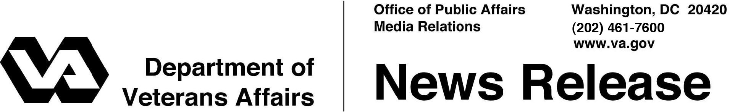
FOR IMMEDIATE RELEASE
February 16, 2012

VA Participates in Settlement with Mortgage Banks
Secretary Announces Protections for Veterans

WASHINGTON – The Department of Veterans Affairs announced its participation in the largest state-federal legal settlement in history that deals with problems within the mortgage industry.

“Through this historic settlement, VA has ensured that Veterans, Servicemembers, and National Guard and Reserve members will continue to receive every possible opportunity to retain their homes,” said Secretary of Veterans Affairs Eric K. Shinseki.
VA joined with the Department of Justice, a coalition of state attorneys general and other federal agencies in the settlement.

The nation’s five largest mortgage servicers have agreed to this landmark $25 billion settlement that addresses past mortgage loan servicing and foreclosure abuses, provides substantial financial relief to borrowers, and establishes significant new homeowner protections in the future.

In addition to cash payments to avoid litigation, the banks also agree to undertake other activities, such as principal forgiveness, interest-rate-reduction refinancing, and forbearance during unemployment.

The settlement also enhances protections available under the Servicemembers Civil Relief Act and provides additional assistance when Servicemembers are forced to sell their home at a loss due to reassignment to another location.

“VA will continue its oversight of lenders and servicers to ensure that Veterans and Servicemembers are able to enjoy the benefits of VA’s home loan program, including access to no-downpayment loans and assistance in retaining their homes should they encounter payment difficulties,” added Under Secretary for Benefits Allison A. Hickey.
-More-
Settlement 2/2/2/2

VA has always provided assistance to Veterans and Servicemembers who experience trouble paying their mortgage, whether they have a VA loan or not. Depending on the situation, VA’s loan specialists can intervene on a Veteran’s behalf to help pursue home-retention options such as repayment plans, forbearances and loan modifications.
To get help, Veterans and Servicemembers – even those without a VA guaranteed loan – may call a national toll-free number, 1-877-827-3702 to speak with VA loan specialists who will provide information about the process of obtaining a VA-guaranteed home loan, or assistance in retaining their home loan or avoiding foreclosure.
Information about the VA Home Loan Guaranty program is also available online at http://www.benefits.va.gov/homeloans. To see videos of Veterans who reached out to VA and were able to keep their homes or avoid foreclosure, please visit www.benefits.va.gov/homeloans/alt-foreclosure.asp.
Since 1944, when home loan guaranties were first offered under the original GI Bill, VA has guaranteed more than 19.4 million home loans worth $1.18 trillion. VA helped over 72,000 (83 percent) Veterans who were in default on their VA guaranteed loan avoid foreclosure in FY 2011, a 10 percent increase from FY 2010. This assistance resulted in a 30 percent reduction in foreclosures over the same year.
VA’s foreclosure rate for the last 14 quarters and serious delinquency rate for the last 11 quarters have been the lowest of all measured loan types, according to a survey by the Mortgage Bankers Association.

# # #

