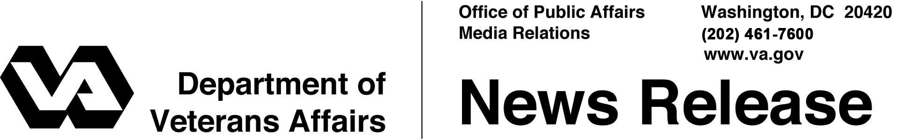

FOR IMMEDIATE RELEASE
March 29, 2012

Louisiana National Cemetery Dedicated
New Cemetery Will Honor America’s Veterans
WASHINGTON – The Department of Veterans Affairs (VA) held a dedication ceremony Saturday in Zachary, La., for the Louisiana National Cemetery, which is expected to open for burial this summer.
“To offer full burial options for the Veterans of East Baton Rouge Parish and the surrounding area is a top priority,” said Secretary of Veterans Affairs Eric K. Shinseki. “With the Louisiana National Cemetery, we are keeping our commitment to provide a final resting place and lasting tribute to the men and women who have kept their commitment to protect and defend our nation.”
Secretary Shinseki gave the keynote address and was joined by elected officials as the dedication plaque was unveiled. Military honors included a firing detail by Weapons Company, 3rd Battalion, 23rd Marines. The U.S. Navy Band New Orleans performed.
The nearby Port Hudson National Cemetery will close to casketed burials in July 2012, although it will stay active with casketed interments of those with family members already buried there. Space for cremated remains is expected to be depleted in 2015. More than 14,000 military service members, Veterans and family members are interred there.
Louisiana National Cemetery is 1.5 miles from Port Hudson National Cemetery on 103.8 acres of land. Construction underway includes both gravesites and columbarium development (for cremation burials) in two phases, providing a full range of burial alternatives to approximately 293,000 Veterans and eligible family members in the East Baton Rouge Parish and the surrounding area.

-More-

Louisiana National Cemetery Dedication 2/2/2/2
The first phase of construction will be completed in May and will include approximately 17 acres with 2,500 in-ground pre-placed crypts, 1,128 traditional gravesites, an entrance feature, roadway, utilities and infrastructure. The second phase will cover approximately 12 acres, to include an administration building and maintenance complex; a committal service shelter; 1,000 columbarium niches; 1,130 in-ground cremation sites; and a public assembly area. The project will also incorporate systems for water distribution, roads, utilities, signage, landscaping and site furnishings.
The director of Port Hudson National Cemetery for the past three years, Rex Kern, will also direct Louisiana National Cemetery. He is responsible for burial, maintenance and administrative operations at both facilities as well as at Baton Rouge, Alexandria and Natchez National Cemeteries. In 2009, Kern graduated from the year-long Cemetery Director Intern Program at VA’s National Cemetery Administration training center in St. Louis.
Veterans with a discharge other than dishonorable, their spouses and dependent children are eligible for burial in a national cemetery. Military personnel who die on active duty, their spouses and eligible dependents are also eligible. Other burial benefits for eligible Veterans include a burial flag, a Presidential Memorial Certificate and a government headstone or marker – even if they are not buried in a national cemetery.
Information on VA burial benefits can be obtained from national cemetery offices, from the Internet at http://www.cem.va.gov or by calling VA regional offices toll-free at 800-827-1000. Additional information about the Louisiana National Cemetery is available by calling the Port Hudson National Cemetery office at 225-654-3767.
# # #

