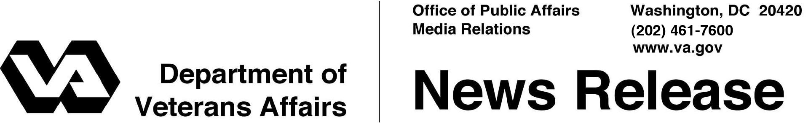

FOR IMMEDIATE RELEASE
June 14, 2011

VA’s Mail-Order Pharmacy Program Recognized
As a J.D. Power 2011 Customer Service Champion

WASHINGTON – The Department of Veterans Affairs’ mail-order pharmacy program has been recognized as a J.D. Power 2011 Customer Service Champion – one of only 40 entities in the United States to earn the distinction this year.
“We are honored to receive this distinction and be included in this elite group of companies that focus on customer service excellence,” said Rita Brueckner, national quality management officer for VA’s Consolidated Mail Outpatient Pharmacy program.
“Customer satisfaction is our top priority, and we appreciate this external recognition of our efforts.”
VA’s Consolidated Mail Outpatient Pharmacy (CMOP) functions as a virtual extension of VA medical center pharmacies by mailing prescription medications and supplies directly to Veteran patients. Local VA medical center pharmacies almost always process and dispense the initial prescription order; after that, the vast majority of refills are handled via mail-order.
The goal is delivery of medication or supplies to the patient within 10 days of provider or patient request. VA typically gets the prescription delivered in less than five days.
CMOP processed nearly 107 million prescriptions in fiscal year 2010. Every workday, 300,000 Veterans receive medication or supplies from VA.
To qualify for inclusion as a J.D. Powers Customer Service Champion, companies must not only excel within their own industries, but also must stand out among leading brands in 20 major industries evaluated by J.D. Power.

- More -

CMOP 2/2/2/2

Among the five key customer “touch points” measured – including people, presentation, process, product, and price – VA’s mail-order pharmacy program was noted for standing out in price, product, and process among the group.
To identify the J.D. Power 2011 Customer Service Champions, J.D. Power evaluated more than 800 brands. Companies were identified based on customer feedback, opinions, and perceptions gathered primarily from J.D. Power’s syndicated research, as well as additional, supplemental research. This year’s group of 40 represents the highest-performing organizations that deliver service excellence to U.S. customers – both within their respective industries and across all industries measured.
“It’s gratifying to receive such positive customer service feedback from the men and women who have served our country and now rely on VA for their prescriptions,” said Michael Valentino, chief consultant for VA’s Pharmacy Benefits Management Services. “It’s especially rewarding to know our Veterans place such a high value on the Consolidated Mail Outpatient Pharmacy services they receive; this has always been and remains our primary motivation to do the best job we possibly can.”
VA’s Consolidated Mail Outpatient Pharmacy program began in 1994. There are seven mail-order pharmacy sites across the continental United States. They form a network that provides pharmaceutical dispensing services to all 152 VA medical centers, as well as a few select Department of Defense and Indian Health Service sites.

# # #

