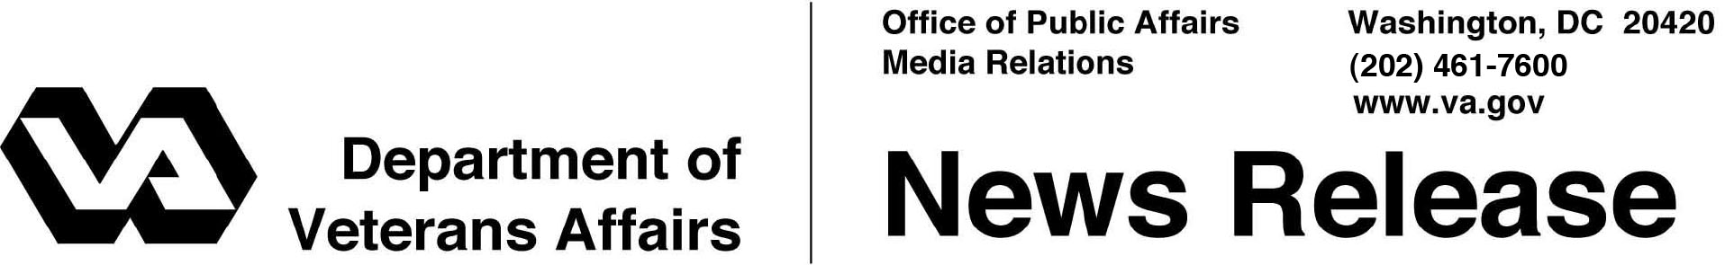

FOR IMMEDIATE RELEASE
January 27, 2012

VA Publishes Regulation on Newborn Care
WASHINGTON – The Department of Veterans Affairs has published a regulation officially amending VA’s medical benefits package to include up to seven days of medical care for newborns delivered by women Veterans who are receiving VA maternity care benefits.
“The regulation change makes formal the commitment VA made to women Veterans,” said Secretary of Veterans Affairs Erik K. Shinseki. “This falls in line with the broad range of services VA is proud to offer women Veterans who have served this nation.”
Newborn care includes routine post-delivery care and all other medically necessary services that are in accord with generally accepted standards of medical practice.
The effective date of the rule is Dec. 19, 2011, but the regulation applies retroactively to newborn care provided to eligible women Veterans on or after May 5, 2011.
VA has women Veterans program managers at every VA medical center to help women Veterans learn more about the health care benefits they have earned with their service. For more information about VA healthcare for women Veterans, visit http://www.womenshealth.va.gov.

# # #

