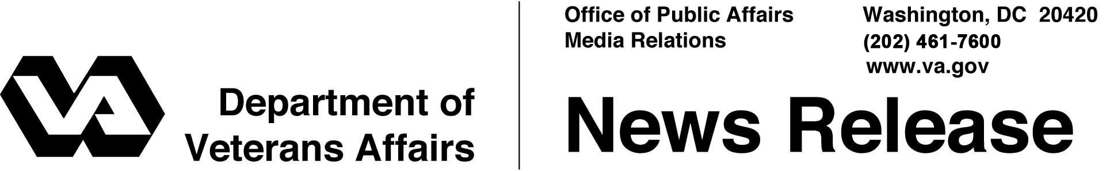

FOR IMMEDIATE RELEASE
August 30, 2011

VA Launches Open Source Custodian
Open Source Electronic Health Record Agent Begins Operations

WASHINGTON – The Department of Veterans Affairs (VA) today announced it has completed an important milestone on its joint path with the Department of Defense (DoD) to create a single electronic health record system for servicemembers and Veterans. OSEHRA, the Open Source Electronic Health Record Agent, has begun operations and will serve as the central governing body of a new open source Electronic Health Record (EHR) community.
"We developed our open source strategy to engage the public and private sectors in the rapid advancement of our EHR software, which is central to the care we deliver to Veterans and servicemembers and to our joint EHR collaboration with the Department of Defense,” said Secretary of Veterans Affairs Eric K. Shinseki. “With the launch of OSEHRA, we begin the implementation of our strategy and we look forward to the creation of a vibrant open source EHR community.”
As part of the initiation of OSEHRA operations, VA has contributed its current EHR, known as VistA (Veterans Integrated System Technology Architecture), to seed the effort. OSEHRA will oversee the community of EHR users, developers, and service providers that will deploy, use, and enhance the EHR software.
Individuals and organizations interested in participating in OSEHRA (www.osehra.org) are invited to join through the community website. Established as an independent non-profit corporation during its initial phase of operation, OSEHRA is putting in place the framework and the tools that will enable the public sector, private industry, and academia to collaborate to advance EHR technology.
- More -
OSEHRA 2/2/2/2

Draft documents describing key framework components, such as the design of its code repository and the definition of its software quality certification process, are available on the OSEHRA community website. Community feedback is welcome as the OSEHRA team finalizes these designs in preparation for launch of full technical operations this fall.
The design of OSEHRA is being led by The Informatics Application Group (tiag) under a contract awarded by VA in June 2011.
Moving to an open source model invites innovation from the public and private sectors. It is an important element of VA’s strategy to ensure that VA clinicians have the best tools possible, and that Veterans receive the best health care possible.
# # #

About OSEHRA
OSEHRA (Open Source Electronic Health Record Agent) governs an open, collaborative community of users, developers, and researchers engaged in advancing electronic health record technology. For more information, visit www.osehra.org.

