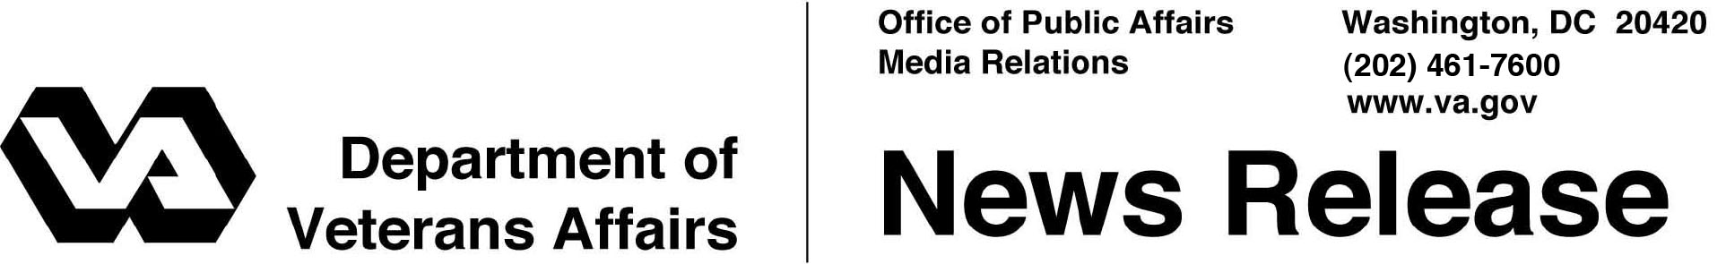

FOR IMMEDIATE RELEASE
July 3, 2012

VA Exceeds Government-Wide Goal for Veteran-Owned Business Procurement

WASHINGTON - The Department of Veterans Affairs exceeded by more than six times the Small Business Administration (SBA) goal of government procurements to Service Disabled Veteran Owned Small Businesses (SDVOSB) according to the SBA scorecard released today. That total surpassed the combined procurements from the rest of the civilian agencies of the federal government.
“Our results demonstrate VA’s commitment to the success of Veteran-owned small businesses,” said Secretary of Veterans Affairs Eric K. Shinseki. “Veterans possess the vision and abilities to help build an enduring and vibrant economy. VA is doing its part to help translate those traits into results.”
VA has statutory responsibilities under Public Law 109-461 that place SDVOSB and Veteran-Owned Small Businesses (VOSB) first and second, respectively, in the hierarchy of its small business preferences.
In support of this policy, Secretary Shinseki has established a department goal of 10 percent for SDVOSB procurements. VA continued to make SDVOSB its first priority even after it met its own expanded goal, resulting in the department nearly doubling its own SDVOSB goal. The Department of Veterans Affairs awarded more than 18.3 percent of its procurement dollars to SDVOSB.
Secretary Shinseki also established a department goal of 12 percent for VOSB. In 2011, VA spent 20 percent of its procurement dollars with VOSB, again far exceeding its own goal.
At the National Veteran Small Business Conference in Detroit last week, the largest crowd of Veteran businesses and government procurement decision makers gathered anywhere in the country this year, Secretary Shinseki announced additional steps to ensure that VA meets its commitment to Veteran-owned businesses.
- Any contract not going to a Veteran-owned small business must be reviewed by a senior executive and concurred with by a senior contracting executive.
- All senior executive performance evaluations will include a small business performance metric.
- For the first time, VA has established small business procurement goals all the way down to the lowest senior executive level that exercises procurement responsibilities; for instance, at a medical center or a regional office or a cemetery. Within overall departmental goals, senior executives are now accountable for specific goals.
For more information about VA’s services for Veteran-owned small businesses, please visit: http://www.vetbiz.gov/.

# # #

