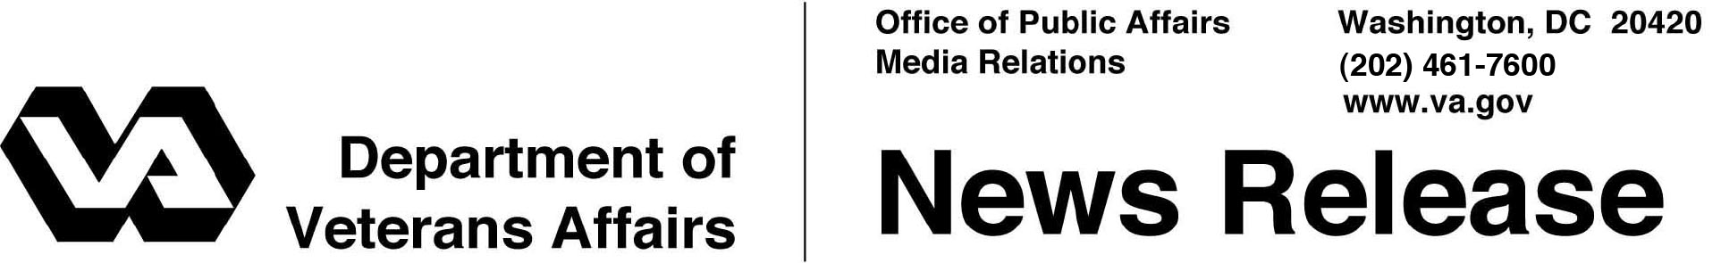

FOR IMMEDIATE RELEASE
February 15, 2012

VA Introduces Text Messaging to Expand Efforts to Prevent Suicide
Veterans Crisis Line Provides Confidential Help to Veterans and Families
WASHINGTON – The Department of Veterans Affairs is expanding its efforts to prevent suicide through several new initiatives that increase the availability of services for Veterans, Servicemembers and their families.
The new initiatives include a new, free, confidential text-messaging service in the existing Veterans Crisis Line, introduction of toll-free access from Europe, and collaboration with Vets Prevail and Vets4Warriors, two groups providing crisis help to Veterans, Servicemembers and their families.
“Offering text messaging services will help VA reach more Veterans and their friends and families,” said Dr. Janet Kemp, VA’s national mental health director for suicide prevention. “We are working to meet their needs by communicating through multiple channels -- over the phone, through online chat, and now via text, which provides quick, easy access to support. VA wants all Veterans to know that confidential support is only a text message away.”
Since its founding July 2007, VA’s Veterans Crisis Line and the later Chat Service have received 500,000 calls and engaged in 31,000 chats resulting in over 18,000 rescues of Veterans in immediate crisis.
Now, in addition to the Veterans Crisis Line (1-800-273-8255 and Press 1) and online chat (www.VeteransCrisisLine.net), Veterans and Servicemembers in crisis—and their friends and families—may text free of charge to 83-8255 to receive confidential, personal and immediate support. The text service is available, like the Veterans Crisis Line and online chat, 24 hours a day, seven days a week, 365 days a year and connects a user with a specially trained VA professional -- many who are Veterans themselves.
-More-
Crisis Hotline 2/2/2/2

As a part of the effort to extend VA’s reach, Veterans and members of the military community in Europe may now receive free, confidential support from the European Military Crisis Line, a new initiative recently launched by VA. Callers in Europe may dial 0800-1273-8255 or DSN 118 to receive confidential support from responders at the Veterans Crisis Line in the U.S.
VA’s Veterans Crisis Line continues to add external resources to provide Veterans with additional support. Two of these organizations include Vets Prevail (www.VetsPrevail.org) and Vets4Warriors (www.Vets4Warriors.com).
In December, Vets Prevail launched a chat service that connects Veterans to caring responders who provide information on a wide variety of resources. If the Veteran is in crisis or needs mental health support, the conversation is then seamlessly transferred to a VA Veterans Crisis Line responder.
Vets4Warriors has helped thousands of their peers connect with confidential assistance through a free hotline (1-855-838-8255/1-855-VET-TALK) and online chat (www.Vets4Warriors.com). If a Veteran is in need of professional crisis or mental health support, Vets4Warriors’ responders will transfer the Veteran to a responder at the Veterans Crisis Line.
For more information about VA’s suicide prevention program, visit: http://www.mentalhealth.va.gov/suicide_prevention/

# # #

